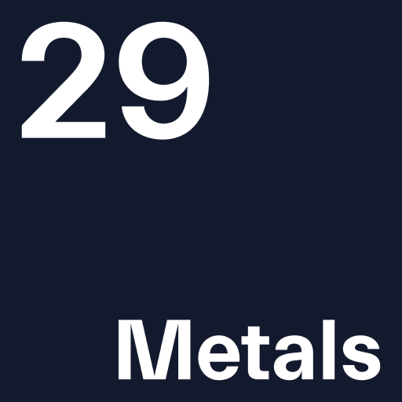

Capricorn Copper Pty Ltd
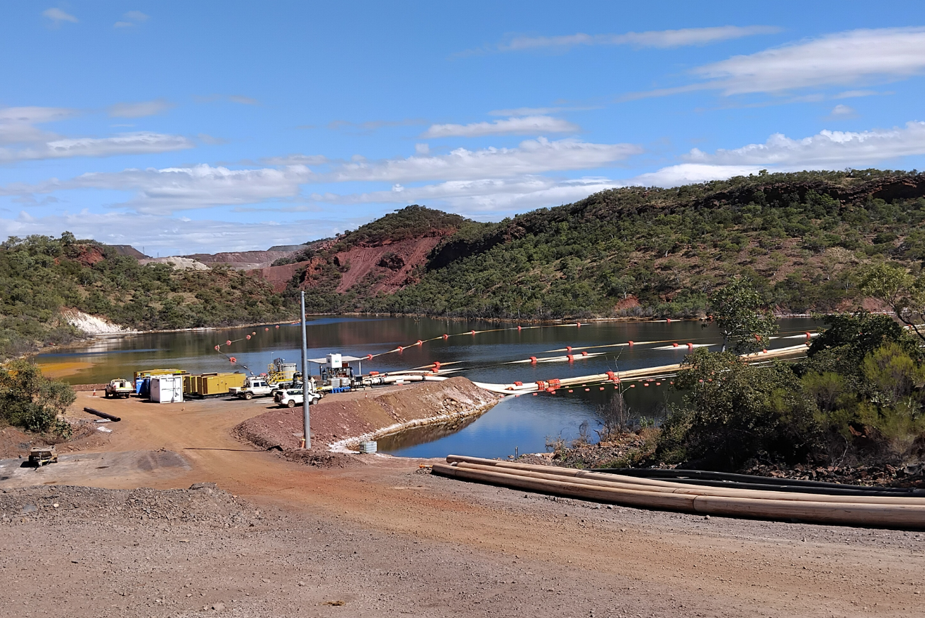

Capricorn Copper Mine
Supporting Information Report
EA Amendment Application for Water Releases
(Conditions C2 & C3)
October 2025

Version Number | Date Issued | Author | Reviewer
Draft V1.0 | 17 October 2023 | K. Grundy  Dr G. McGuire | Dr B. Shean  E. Cooney
Draft V1.1 | 13 January 2024 | K. Grundy  Dr G. McGuire | Dr B. Shean  Dr G. McGuire
Draft V2.0 | 18 June 2024 | K. Grundy  Dr G. McGuire | Dr B. Shean  E. Cooney
Final V3.0 | 19 July 2024 | K. Grundy  Dr G. McGuire  Dr B. Shean | E. Cooney  M. Warnock  M. Longbottom  A. Butler
Final V4.0 | 31/10/2025 | K. Grundy  Dr G. McGuire  Dr B. Shean | Dr G. McGuire  Dr B. Shean

Table of Contents
1. Executive Summary 6
2. Introduction 7
2.1 Background 7
2.1.1. 2023 and 2024 weather events 7
2.1.2. CCM’s response to event and status on site 7
2.1.3. Risk to environment 8
2.2 Overview of EA Amendment Application 8
2.2.1. Challenges with current EA 8
2.2.2. Overview of proposed changes to EA 8
2.2.3. Overview of methods and contents of this submission 8
3. Regulatory Requirements for the EA Amendment Application 9
4. Proposed Amendment 14
4.1 EA Amendment Objective 14
4.2 Proposed EA Condition Amendments 14
5. Receiving environment: interim and long-term contaminant limits and monitoring sites 15
5.1 Summary 15
5.2 DETSI proposed EA framework 15
5.3 Compliance monitoring sites 16
5.3.1. GPA6 Gunpowder Creek Adjacent Receiving Environment Monitoring Site 16
5.3.2. GPD2 Gunpowder Creek Downstream Receiving Environment Monitoring Site 17
5.4 Interim Contaminant Limits 17
5.5 Longer term Contaminant Limits 18
5.6 Historical data comparison to proposed receiving waters contaminant limits and trigger levels 19
5.6.1. Electrical Conductivity 20
5.6.2. Sulphate 22
5.6.3. Aluminium 23
5.6.4. Cobalt 24
5.6.5. Copper 25
5.6.6. Uranium 26
5.6.7. Zinc 26
6. Release of treated MAW: Quality and Conditions 28
6.1 Treated water contaminant release limits 28
6.1.1. Dissolved metal contaminant release limits 29
6.1.2. Sulphate contaminant release limit 29
6.1.3. Total suspended solids contaminant release limit 29
6.1.4. Electrical conductivity contaminant release limit 30
6.2 Contaminant dilution modelling 30
6.3 Risk assessment of proposed EA release water limits and conditions 31
6.3.1. Environmental Values of water 31
6.3.2. Assessment of 2024/25 release event receiving water quality 32
6.3.3. Risks to other EVs - total metal concentrations 34
7. CCM Water Management System 37
7.1 Strategy – treatment and release 37
7.2 Site infrastructure and systems 38
7.2.1. Recycling of MAW 38
7.2.2. Evaporators 38
7.2.3. Real-time water quality monitoring stations 38
7.2.4. Full refurbishment and upgrade of lime slaking plant 39
7.2.5. Temporary Water Treatment Plant 39
7.2.6. Permanent Water Treatment Plant 39
7.2.7. MCD bulk treatment 40
7.3 Compliance and management response to exceedances 40
7.3.1. Laboratory analysis reported exceedance 41
7.3.2. Monitoring station exceedance and automated release management 41
8. Environmental Values Assessment 43
8.1 Air 43
8.2 Acoustic 43
8.3 Water 44
8.4 Waste 45
8.5 Land 45
8.6 Land Use 47
9. Risk Assessment 48
9.1 Consequence Rating 48
9.2 Likelihood Rating 48
9.3 Risk Ranking 49
9.4 Risk Assessment 49
10. Stakeholder Engagement 51
11. References 53

List of Tables
Table 1: Requirements of Sections 226 and 226A of the EP Act 10
Table 2: Minor amendment (threshold) criteria 12
Table 3: Receiving Waters Interim Contaminant Limits 17
Table 4: Receiving Waters Trigger Levels and Contaminant Limits 19
Table 5. Historical EC data summary (>2m³/s flows) 20
Table 6. Historical sulphate data summary (>2m³/s flows) 22
Table 7. Historical dissolved aluminium data summary (>2m³/s flows) 23
Table 8. Historical dissolved cobalt data summary (>2m³/s flows) 24
Table 9. Historical dissolved copper data summary (>2m³/s flows) 25
Table 10. Historical dissolved zinc data summary (>2m³/s flows) 26
Table 11. Contaminant Release Limits 28
Table 12. Dilution modelling outputs 31
Table 13. 2024/25 release water quality summary 32
Table 14. 2024/25 release event receiving water quality summary 33
Table 15. 2024/25 release water quality risk to livestock 35
Table 16. 2024/25 release event receiving water quality risk to livestock 36
Table 17: Consequence of an event 48
Table 18: Likelihood of an event 48
Table 19: Risk Ranking 49
Table 20: Risk Assessment of Wet Season Release EA Amendment 49
Table 21: Community engagements relevant to CCM contaminated water inventory and management measures 51

List of Figures
Figure 1. Receiving water monitoring site GPA6 in relation to Gunpowder Creek dry season pools 16
Figure 2. EC interim and long-term contaminant limits and trigger level compared to historical adjacent and downstream site data (>2m³/s flows) boxplots 20
Figure 3. EC interim and long-term contaminant limits and trigger level compared to historical adjacent and downstream site data (>2m³/s flows) over time 20
Figure 4. Continuous EC measurements during 2024/25 Wet Season Release Event 1, Release Event 2 and Release Event 3 21
Figure 5. Sulphate default livestock (cattle) protection limit compared to historical adjacent and downstream site data (>2m³/s flows) boxplots 22
Figure 6. Sulphate default livestock (cattle) protection limit compared to historical adjacent and downstream site data (>2m³/s flows) over time 22
Figure 7. Dissolved aluminium interim and long-term contaminant limits and trigger level compared to historical adjacent and downstream site data (>2m3/s flows) boxplots 23
Figure 8. Dissolved aluminium interim and long-term contaminant limits and trigger level compared to historical adjacent and downstream site data (>2m3/s flows) over time 23
Figure 9. Dissolved cobalt interim and long-term contaminant limit/trigger level compared to historical adjacent and downstream site data (>2m3/s flows) boxplots 24
Figure 10. Dissolved cobalt interim and long-term contaminant limit/trigger level compared to historical adjacent and downstream site data (>2m3/s flows) over time 24
Figure 11. Dissolved copper interim and long-term contaminant limits and trigger level compared to historical adjacent and downstream site data (>2m3/s flows) boxplots 25
Figure 12. Dissolved copper interim and long-term contaminant limits and trigger level compared to historical adjacent and downstream site data (>2m3/s flows) over time 25
Figure 13. Dissolved zinc interim/long-term contaminant limit and trigger level compared to historical adjacent and downstream site data (>2m3/s flows) boxplots 26
Figure 14. Dissolved zinc interim/long-term contaminant limit and trigger level compared to historical adjacent and downstream site data (>2m3/s flows) over time 27
Figure 15: EC as a function sulphate assays for all untreated and treated MAW samples taken on site from 2023 – 2024 30
Figure 16. Electrical conductivity at adjacent and downstream receiving environment monitoring sites during the 2024/25 wet season release events 34
Figure 17. Dissolved cobalt at adjacent and downstream receiving environment monitoring sites during the 2024/25 wet season release events 34
Figure 18: CCM site flowsheet for water treatment and release systems 37
Figure 19: Completed MCD bulk treatment and release system (May 2024) 40
Figure 20: Real-time Creek Monitoring Stations 42

Appendices
Found as separate documents:
Appendix A – Draft amended Environmental Authority EPML00911413

Appendix B – Engeny (2023) Release Assessment

Executive Summary
Capricorn Copper Pty Ltd (CCPL) operates the Capricorn Copper Mine (CCM) located at Gunpowder in North Queensland, which is regulated by Environmental Authority (EA) EPML00911413 (dated 23 May 2025).
The treatment and release of Mine Affected Water (MAW) is an important mechanism for ensuring MAW does not accumulate onsite during extreme wet season events such as the event in March 2023, increasing the risk of uncontrolled release and potential environmental harm to the receiving environment. This method of managing water inventory is used by several other mining sites in the region and can have minimal impacts on the environment when completed in accordance with carefully selected parameters that ensure environmental protection.
EPML00911413 allows for a maximum volume of treated MAW to be released over a 72-hour period (70,000 cubic metres, Condition C2-4) and 12-month period (500,000 cubic metres, Condition C2-5). A release assessment prepared by Engeny (2023) identifies the annual and 72-hour caps on release volumes as the largest limitation to estimated release potential of treated MAW. Therefore, removal of these caps will increase the estimated annual release opportunity and assist returning the site to compliance associated with surface water inventories. More stringent contaminant release limits and higher base flows in Gunpowder Creek can be incorporated to minimise the risks from higher release volumes.
CCPL has prepared this amendment application to remove maximum volume limits, and in doing so, release a higher volume of water over a single wet season. Uncontrolled discharge of MAW to Gunpowder Creek could be catastrophic to the Gunpowder Creek ecosystem and further downstream, and poses risk to humans and stock that have access to the discharged water.
In addition to this, CCPL is proposing an amendment to release limits and modernising of receiving environment assessment conditions. Through the process of preparing this application and undertaking the required specialist studies, CCPL has considered the relationship between the background flows and quality of Gunpowder Creek, the quality and volume of treated MAW proposed for release, the predicted concentration of contaminants in the receiving water and data from the 2024/25 release events. This method of assessment was not applied to the current or earlier versions of the EA, and it provides a greater level of certainty and scientific robustness to this application.
The application presents an improvement to the EA in regard to environmental protection. CCPL now has a greater understanding of the receiving environment responses to different creek flows and water quality, and higher confidence that releases undertaken in accordance with the amended conditions presented in this application will not result in harm to the environmental values of Gunpowder Creek and the surrounding environment. Technical studies and 2024/25 release data demonstrate that releases undertaken in accordance with proposed amended conditions pose a lower risk of environmental harm that those undertaken in accordance with the current EA.
Supporting reports provided with this amendment application include:
- Draft amended Environmental Authority EPML00911413

- Engeny (2023) Release Assessment.

Introduction
Capricorn Copper Pty Ltd (CCPL) operates the Capricorn Copper Mine (CCM) located at Gunpowder in North Queensland, which is regulated by Environmental Authority (EA) EPML00911413.

Background
    - 2023 and 2024 weather events
During March 2023, a weather system in north western and central Queensland resulted in heavy rainfall in and around the tenements of CCM, located approximately 120 km north west of Mount Isa. The extreme weather event resulted in significant inflows to the mine affected water (MAW) system and inundation of the Esperanza Underground Mine and Workshop/Warehouse areas. The 3-day total of 431.4 mm is the largest ever recorded in 133 years of rainfall records, well above the 99th percentile, and has been determined as 1 in 200 Annual Exceedance Probability (AEP). The 7-day total of 560.8 mm is also the largest on record and determined as a 1 in 200 to 1 in 500 AEP.
As a result of this weather event, MAW storage in both Mill Creek Dam (MCD) and Esperanza Pit (EPit) exceeded the maximum operating level (MOL) with an estimated additional circa 500 ML in the underground workings requiring dewatering to EPit before mining could recommence in Esperanza South.
Following on from the extreme weather event in March 2023, the Capricorn Copper site received higher than average rainfall in January, February and March 2024 as a result of the impact of successive Tropical Cyclones – Kirrily, Lincoln and Megan.
Tropical Cyclone Kirrily was a long-lived and strong tropical cyclone that affected East Australia and the Northern Territory during January and February 2024. TC Kirrily, developed from a tropical low that formed in the Coral Sea, and made landfall northwest of Townsville on 25 January 2024 as a Category 3 severe tropical cyclone. After landfall, TC Kirrily moved westwards as a tropical low resulting in heavy rainfall around the Mount Isa region including Gunpowder.
Tropical Cyclone Lincoln initially formed as a tropical low on 6 February 2024 over northern Australia between the Joseph Bonaparte Gulf and the Gulf of Carpentaria. TC Lincoln made landfall on the Gulf of Carpentaria coast between Port McArthur and the Northern Territory—Queensland border just after 06:00 UTC on 16 February 2024 as a Category 1 tropical cyclone. As the system degenerated into a tropical low it resulted in heavy rainfall around Gunpowder before turning westward and reforming off Western Australia.
Tropical Cyclone Megan initially formed as a tropical low in the Gulf of Carpentaria. TC Megan formed in the early evening of 16 March 2024. and made landfall on the south-western Gulf of Carpentaria as a Category 3 system during Monday 18 March 2024. The TC resulted in strong winds of up to 200 kilometres per hour, heavy rainfall and extensive flooding in communities across the Northern Territory. Rainfall and storm systems associated with TC Megan extended into NW Qld. Background flows in Gunpowder Creek as a result of rainfall associated with TC Megan reached up to 450 cumecs (local).
    - CCM’s response to event and status on site
CCPL have introduced a number of improvements to the site water management system following the 2023 extreme wet season event including recycling of MAW for mining purposes, and installation of additional evaporators on the EPit. Despite the improvements, CCPL were unable to release enough treated water during the 2023/24 wet season to significantly reduce the volume of water stored on site due to significant weather events impacting the area (described above) and further adding to the inventory.
Continued improvement to CCPL’s water management strategy includes commissioning of infrastructure for a bulk treatment and release system in the MCD (MAW neutralisation using lime dosing) and the conversion of the process plant to also treat MAW whilst operations are suspended. In parallel, CCPL has engaged Ausenco to undertake detailed design of a new and significantly larger water treatment plant. Due to the combined risk of excessive water inventory on site and the lack of tailings storage capacity on site, operations were suspended in April 2024. CCPL’s intention is to focus on inventory reduction during the upcoming wet season (through evaporation and wet season releases) while additional tailings storage capacity options are investigated, approved and constructed.
    - Risk to environment
The treatment and release of MAW is an important mechanism for ensuring MAW does not accumulate onsite during extreme wet season events, increasing the risk of uncontrolled release and potential environmental harm to the receiving environment over consecutive wet seasons.
For this reason it is critical that an EA amendment is approved to enable increased release volumes (and hence a controlled reduction of inventory).

Overview of EA Amendment Application
    - Challenges with current EA
There are a number of challenges with the existing EA that have been addressed in this amendment, including but not limited to the following:
- A 72-hour period (70,000 cubic metres) and 12-month period (500,000 cubic metres) maximum release limit. This limits CCM’s ability to discharge MAW accumulated over a short period, for example, from an extreme weather event.
- The current aquatic ecosystem WQOs are often exceeded in Gunpowder Creek adjacent to the mine. The area has been impacted by historic mining disturbance and legacy infrastructure.
- High total metal release limits have been of concern to the Department of Environment, Tourism, Science and Innovation (DETSI) for some time, and currently cannot be related to aquatic ecosystem WQOs that are applied to the dissolved metal fraction.
- Impractical timeframes for sample collection, lab analysis and reporting.
    - Overview of proposed changes to EA
The primary objective of this proposed EA Amendment is to remove maximum release volume limits set in conditions C2-4 and C2-5 of the current EA.
CCPL have also taken the opportunity to:
- assess and reduce contaminant release limits provided in Schedule C - Table 2,
- allow for flexibility in the release strategy with inclusion of two release water qualities and associated dilution ratios and maximum release rates,
- increase the minimum background flow rate,
- amend receiving water monitoring locations provided in Schedule C - Table 3 (including inclusion of a highly disturbed zone),
- include real-time monitoring of release and receiving waters, and
- modernise the receiving water protection values provided in Schedule C - Table 4.
Additional amendments that feed into those conditions are also included. Proposed amendments are presented in a draft amended EA (track changes) provided in Appendix A.
    - Overview of methods and contents of this submission
The process for developing proposed amendments to the EA, that ensured no harm to the environment, was as follows:
- Modelling of wet season releases to understand limitations to controlled release of MAW from site.
- Risk assessment to determine applicable Environmental Values (EVs) and assess potential impacts from the proposed amendment.

- Multiple pre-lodgement meetings with DETSI and the OCG and revision of application material in response to pre-lodgement meeting outcomes.
- Assessment of CCM’s temporary Water Treatment Plant (WTP) output water quality over the 2024/2025 wet season.
- Consideration of DETSI’s Information Request (IR), DETSI’s draft EA framework Parts 1, 2 & 3, outcomes of the DETSI/CCPL technical workshop (18/9/2025), new WTP data, and full revision of proposed water quality limits and triggers.
- Revision of application material (this supporting report) in response to post-IR meetings and communications with DETSI.

Regulatory Requirements for the EA Amendment Application
The information presented in this supporting document has been prepared in accordance with the requirements in the Queensland Environmental Protection Act 1994 (EP Act) and its subordinate Environmental Protection Regulation 2019 (EP Reg).
Sections 226 and 226A of the EP Act (current as at 26 June 2024) specify the requirements for an EA amendment application. Table 1 shows how the original EA amendment application and the supporting information met the requirements of Sections 226 and 226A of the EP Act.
Section 228 of the EP Act requires that the administering authority must, after receiving an amendment application, decide whether the proposed amendment is a major or minor amendment. The assessment criteria to determine if an application is a minor amendment (threshold) are outlined in Section 223 of the EP Act.
Table 2 provides an explanation for each of the criteria relevant to this amendment application. CCPL and its technical advisers have reviewed the minor EA amendment thresholds and considered that the application met the criteria for a minor amendment as it will provide a reduction in the risk of environmental harm.
The EA Amendment application was deemed properly made and determined to be a major amendment by DETSI on 19 August 2024. This report has been amended as part of CCPL’s response to DETSI’s Information Request. Table 1 and Table 2 are no longer relevant to the process as determinations have been made, however the tables have been retained as part of the original application submission.

Table 1: Requirements of Sections 226 and 226A of the EP Act
Requirements for amendment application¹ | Addressed by EA amendment application and supporting information
S.226 (1) An amendment application must -
(a) be made to the administering authority; and | The EA amendment application will be lodged with DESI via the online portal.
(b) be in the approved form; and | The EA amendment application has been made using the administering authority’s online portal.
(c) be accompanied by the fee prescribed by regulation; and | The prescribed fee will be paid alongside the application submission.
(d) describe the proposed amendment; and | The proposed amendments are described in Section 4.2.
(e) describe the land that will be affected by the proposed amendment; and | The EA amendment applies to MLs listed on EA EPML00911413: ML5407, ML5412, ML5413, ML5418, ML5419, ML5420, ML5429, ML5430, ML5441, ML5442, ML5443, ML5444, ML5451, ML5454, ML5457, ML5459, ML5467, ML5485, ML5486, ML5489, ML5500, ML5548, ML5549, ML5550, ML5562, ML5563, ML90180, ML90181 and ML90182.
(f) include any other relevant document relating to the application prescribed by regulation. | Supporting technical documents are attached.
S.226A (1) If the amendment application is for the amendment of an environmental authority, the application must also -
(a) describe any development permits in effect under the Planning Act for carrying out the relevant activity for the authority; and | There are no development permits for the relevant activity.
(b) state whether each relevant activity will, if the amendment is made, comply with the eligibility criteria for the activity; and | The application is to amend a site-specific EA; therefore, eligibility criteria are not relevant.
(c) if the application states that each relevant activity will, if the amendment is made, comply with the eligibility criteria for the activity – include a declaration that the statement is correct; and | Not applicable.
(d) state whether the application seeks to change a condition identified in the authority as a standard condition; and | Not applicable.
(e) if the application relates to a new relevant resource tenure for the authority that is an exploration permit or GHG permit – state whether the applicant seeks an amended environmental authority that is subject to the standard conditions for the relevant activity or authority, to the extent it relates to the permit; and | The application does not relate to a new tenure.
- include an assessment of the likely impact of the proposed amendment on the environmental values, including –  - a description of the environmental values likely to be affected by the proposed amendment; and  - details of emissions or releases likely to be generated by the proposed amendment; and  - a description of the risk and likely magnitude of impacts on the environmental values; and  - details of the management practices proposed to be implemented to prevent or minimise adverse impacts; and  - if a PRCP schedule does not apply for each relevant activity – details of how the land the subject of the application will be rehabilitated after each relevant activity ends; and | Relevant impact assessment information is provided in this report (Section 8). Water management systems and practices are provided in Section 7.  A risk assessment has been completed in Section 9.  A PRCP schedule does not apply to the activity. The proposed amendment is in relation to the volume of water released from site only and does not require any additional or change to land disturbance. Therefore, land rehabilitation is not relevant to the proposed amendment.
(g) include a description of the proposed measures for minimising and managing waste generated by amendments to the relevant activity; and | Waste management will not be affected by the amendment. CCPL’s Waste Management Plan has previously been provided to DESI.
(h) include details of any site management plan or environmental protection order that relates to the land the subject of the application. | CCM is not currently operating under any Environmental Protection Order (EPO).
1 Source: Sections 226 and 226A of the EP Act, current as at 2 June 2023.

Table 2: Minor amendment (threshold) criteria
Minor amendment (threshold) criteria¹ | Explanation for amendment
Minor amendment, for an environmental authority or PRCP schedule, means an amendment that is—
- for an environmental authority—  - a condition conversion; or  - a minor amendment (threshold); | The amendment meets the criteria for a minor amendment (threshold) as described in the following sections. No additional land disturbance or increase in mining activity is proposed, and there is no associated increase to the potential for environmental harm as detailed in the supporting technical assessments.
Minor amendment (threshold), for an environmental authority, means an amendment that—
- is not a change to a condition identified in the authority as a standard condition, other than—  - a change that is a condition conversion; or  - a change that is not a condition conversion but that replaces a standard condition of the authority with a standard condition for the environmentally relevant activity to which the authority relates; or  - a change that will not result in a change to the impact of the relevant activity on an environmental value; and | The amendment is not a change to a condition identified in the authority as a standard condition.
- does not significantly increase the level of environmental harm caused by the relevant activity; and | The proposed amendment does not impose any new risks, helps reduce existing risks, and does not increase the level of environmental harm, as evidenced in the supporting technical assessments.  Key considerations include:  - The 2023 Annual REMP Report (Appendix C) shows that aquatic ecosystem values have not been impacted by release waters that meet the current Contaminant Release Limits.  - Proposed Contaminant Release Limits in this amendment are lower than current Contaminant Release Limits in the EA and dilution ratios are higher, meaning actual impact on the creek system (in terms of metal and metalloid concentration) will be lower under the amended EA.  - The amendment will greatly reduce the existing and ongoing risk of uncontrolled releases of MAW by increasing the opportunity to remove treated MAW from site in a controlled manner.
- does not change any rehabilitation objectives stated in the authority in a way likely to result in significantly different impacts on environmental values than the impacts previously permitted under the authority; and | The amendment has no effect on the rehabilitation objectives of the project.
- does not significantly increase the scale or intensity of the relevant activity; and | The amendment does not relate to the scale or intensity of the mining activity.
- does not relate to a new relevant resource tenure for the authority that is—  - a new mining lease; or  - a new petroleum lease; or  - a new geothermal lease under the Geothermal Energy Act; or  - a new GHG injection and storage lease under the GHG storage Act; and | The proposed amendment does not relate to a new relevant resource tenure.
- involves an addition to the surface area for the relevant activity of no more than 10% of the existing area; and | The proposed amendment will not increase the surface area for the relevant activity by more than 10% of the existing area.
- for an environmental authority for a petroleum activity—  - involves constructing a new pipeline that does not exceed 150km; or  - involves extending an existing pipeline so that the extension does not exceed 10% of the existing length of the pipeline; and | The proposed amendment is not for a petroleum activity.
- if the amendment relates to a new relevant resource tenure for the authority that is an exploration permit or GHG permit—seeks, in the amendment application under section 224, an amended environmental authority that is subject to the standard conditions for the relevant activity or authority, to the extent it relates to the permit. | The proposed amendment does not relate to a new relevant resource tenure.
1 Source: Section 223 of the EP Act, current as at 2 June 2023.

Proposed Amendment
This section serves to give a summary of all proposed changes. The methods, reasoning and substantiation for these proposed amendments are presented in Sections 5 and 6.

EA Amendment Objective
The objective of this application is to:
- reduce contaminant release limits provided in Schedule C - Table 2,
- allow for flexibility in the release strategy with inclusion of two release water qualities and associated dilution ratios and maximum release rates,
- remove the 72-hour and 12 -month release volume limits,
- increase the minimum background flow rate,
- amend receiving water monitoring locations provided in Schedule C - Table 3,
- include real-time monitoring of release and receiving waters, and
- incorporate interim (Schedule C - Table 4) and long-term (Schedule C – Table 4) receiving water protection limits and triggers.

Proposed EA Condition Amendments
Proposed EA amendments are provided in a track-changed draft EA in pdf and Microsoft Word formats (Appendix A).

Receiving environment: interim and long-term contaminant limits and monitoring sites

Summary
Hydrobiology were engaged by CCPL to undertake scientific assessments of the relationships between release limits, predicted and historic receiving environment water quality and the aquatic ecosystem of Gunpowder Creek.
Hydrobiology conducted a comprehensive technical assessment of the Gunpowder Creek receiving environment to ascertain relevant EVs and assess proposed receiving water WQOs. A risk assessment was then undertaken to determine the risk of impacts to the receiving environment from releases of treated MAW with contaminant concentrations at the proposed release limits (e.g. maximum toxicant concentrations). The assessment involved release modelling using background water quality, proposed release water quality (different qualities defined) and dilution rate, and other model inputs as defined in Section 2.4.1.1 of the Receiving Environment Risk Assessment. The predicted receiving environment toxicant concentrations were then compared to the WQOs to identify potential impacts to EVs.
Initial modelling identified predicted concentrations of dissolved copper and cobalt as posing a residual risk to aquatic ecosystems, one of the EVs defined for the receiving environment. This did not align with findings of the receiving environment monitoring program (REMP) that shows no significant differences between reference and receiving environment aquatic ecosystem communities, suggesting that existing WQOs for copper and cobalt are not suitable for assessment of water quality impacts to Gunpowder Creek. However, DETSI were not accepting of the methods used to determine limits for cobalt and copper and requested, via an Information Request issued 18 September 2024, for alternative methods to be applied.
Since the initial EA Amendment application and through the Information Request stage, CCPL and DETSI have undertaken detailed assessments of CCM’s receiving environment water quality dataset, identifying several variables that should be considered in the development and application of compliance assessment and identification of environmental harm. Monitoring site GPA2 is upstream of the release point W1 on Gunpowder Creek and is suitable as a reference site for assessment of release event impacts. However, during nil to low flow periods (<2 m³/s) GPA2 has been shown to be impacted by seepage and best serves as a compliance site at these times (nil to low flows). Additionally, sites adjacent and downstream of the mine are characterised by a variable range of elevated results during dry periods as water holes dry out, metals become concentrated and seepage contributes to the elevated levels. Site-specific contaminant limits are suitable for assessment of potential non-release related mining impacts and detection of declining water quality trends at these sites. During high flows, the Greenstone Creek crossing used to access downstream sites (GPD) becomes submerged and unpassable. This has severely limited the downstream dataset relevant to high flow events (>2 m³/s) and made it difficult to assess the suitability of long-term contaminant limits at this time.
Between 17 April and 13 June 2025, DETSI issued a proposed EA framework to introduce a temporary approval approach (referred to as Part 1) to support amendments to release water contaminant release limits (Part 2) and longer term receiving contaminant limits (Part 3). The proposed framework and assumptions were reflective of findings outlined in the above paragraph and detailed further in the next section.

Further to the proposed EA framework, DETSI and CCPL technical leads attended a technical workshop on 18 September 2025. Two recommendations made by DETSI during the workshop were the introduction of total metal release contaminant limits and the reintroduction of trigger levels for long-term compliance assessment.

DETSI proposed EA framework
DETSI’s proposed approach included a 2-3 year period where temporary (referred to in this document and Appendix A as ‘interim’) contaminant limits would apply to water quality at compliance monitoring sites. Compliance sites would include two adjacent (GPA) and one downstream (GPD) monitoring site on Gunpowder Creek during nil to low flow periods (<2 m³/s); one downstream site on Gunpowder Creek (GPD) during high flow events (>2 m³/s), and a supporting cease release trigger applicable to continuous monitoring of pH and EC at an adjacent site (GPA).
The approach relies on dedicated sampling of downstream sites (GPD) during the interim period to address the high flow (>2 m³/s) data gap. CCPL have committed to providing all weather access across Greenstone Creek in response to DETSI’s proposed approach.
Interim nil to low flow metal contaminant limits were proposed to be site-specific, based on 95th percentiles of data from the site location or ANZG (2018) default guideline values (DGVs) for ecosystem protection, whichever was higher.
Interim high flow metal contaminant limits were proposed to be 95th percentiles of reference site data or ANZG (2018) DGVs for ecosystem protection, whichever was higher.
DETSI’s proposed contaminant release limit framework reflected CCPL’s earlier proposal, with minor suggestions.
Longer term metal contaminant limits were proposed to be 95th percentiles of reference site data and apply to both adjacent and downstream sites, with no direction on nil to low flow or high flow treatment.

Compliance monitoring sites
In DETSI’s proposed EA framework, DETSI proposed GPA2, GPA7 and GPD1 as the draft interim nil to low flow compliance sites, and GPD1 as the draft interim high flow compliance monitoring site with various adjacent sites proposed for selection of a cease release trigger site (not a compliance site).
CCPL have proposed GPA2, GPA6 and GPD2 as the interim nil to low flow compliance sites, and GPD2 as the interim high flow compliance monitoring site with GPA4 continuous monitoring station used as an early cease release trigger site (not a compliance site).
CCPL have proposed GPA2, GPA4, GPA6, GPD2, MGA1 and GS2 as longer term compliance sites.
    - GPA6 Gunpowder Creek Adjacent Receiving Environment Monitoring Site
Monitoring site GPA6 was proposed as a dry season monitoring site in the original EA amendment application due to the permanency of water at this site compared to nearby site GPA7. CCPL have, on multiple occasions, provided evidence to DETSI supporting the use of GPA6 as a nil to low flow site, and have reinstated safe access to the site in preparation for the 2025/2026 wet season. The image below clearly depicts the suitability of GPA6 as a nil to low flow monitoring site.
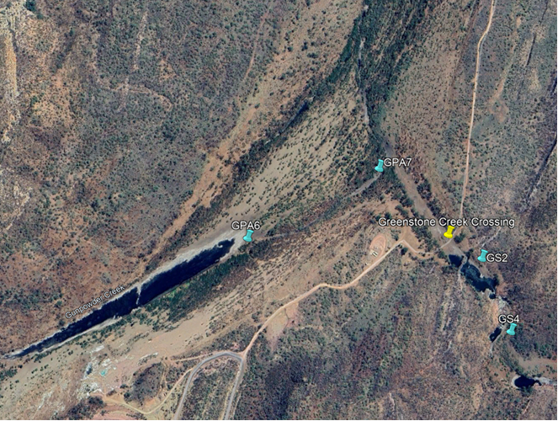
Figure 1. Receiving water monitoring site GPA6 in relation to Gunpowder Creek dry season pools
In addition to the permanency of water, GPA7 has also reported elevated results which are not reflective of upstream or downstream conditions. The GPA7 monitoring site is located on the secondary branch of a braided section of Gunpowder Creek where water flow ceases earlier than that of the northern, primary branch of the braided channel. GPA7 is likely capturing and concentrating contaminated water from mining-related sources independent of release waters (e.g. seepage). Whilst the cause of elevated results at GPA7 warrants further investigation, the use of GPA4, GPA6 and GPD2 is recommended for assessment of treated water releases in preference to GPA7.
    - GPD2 Gunpowder Creek Downstream Receiving Environment Monitoring Site
Selection of GPD2 as a compliance monitoring site was based on results of a risk assessment in accordance with CCPL’s obligations under the Mining and Quarrying Safety & Health Act (1999) and Regulations (2017). DETSI’s preferred site GPD1 was identified as being the highest risk monitoring location due to the following characteristics:
- A steep uneven surface, facing towards the creek
- Loose and unstable rocks
- Isolated location with high difficultly of retrieving an injured individual.
Monitoring site GPD2 has been proposed as a substitute for downstream compliance monitoring as per the Mining and Quarrying Safety & Health Regulations (2017). GPD2 has been assessed to pose a low safety risk and is likely to be suitable as both a nil to low flow and high flow monitoring site, subject to continued all-weather access across Greenstone Creek.

Interim Contaminant Limits
Proposed interim nil to low flow and high flow contaminant limits are presented in Table 3. The source or basis of each limit is provided in the table footnotes. Generally:
- GPA2 contaminant limits are based on the 95th percentile of GPA2 data collected between 2020 and 2024 (following water quality improvement in response to seepage intervention improvements) during nil to low flow periods, GPU1 95th percentile during nil to low flow periods or published guideline values, which ever was higher.
- GPA6 contaminant limits are based on the 95th percentile of pooled adjacent site data (excluding GPA2) collected during nil to low flow periods, GPU1 95th percentile during nil to low flow periods or published guideline values, which ever was higher.
- GPD2 nil to low flow contaminant limits are based on the 95th percentile of pooled downstream site data collected during nil to low flow periods, GPU1 95th percentile during nil to low flow periods or published guideline values, which ever was higher.
- CCPL proposed contaminant limits based on livestock guidelines were not supported by DETSI as they are not protective of aquatic ecosystems. During the DETSI and CCPL workshop on 18 September 2025, DETSI expressed their preference for sulphate analysis “for interpretation purposes” as the proposed EC limit is considered sufficiently protective of aquatic ecosystems.
- GPD2 high flow contaminant limits are based on the 95th percentile of GPA2 data collected during high flow periods (excluding 2023 extreme weather event elevated results), GPU1 95th percentile during high flow periods or published guideline values, which ever was higher.
- The GPD2 and GPA4 high flow EC limit is the 90th percentile of Queensland Gulf freshwater data, as presented in the Queensland Water Quality Guidelines (2009).
Table 3: Receiving Waters Interim Contaminant Limits
Parameterª | Nil to low background flow (<2 m³/s) |  |  | High background flow (=>2 m³/s)
Parameterª | Contaminant limit |  |  | Contaminant limit | Cease release trigger
Parameterª | GPA2 | GPA6 | GPD2 | GPD2 | GPA4
pH (pH units) | 6.5 – 8.7 ^{d} | 6.5 ^{b} - 8.7 ^{d} | 6.5 – 9.2 ^{h} | 6.5 – 8.5 ^{b}
EC (µS/cm) | 2,867 e | 3,062 ^{g} | 1,270 ^{h} | 630 ^{i} | 630 ^{i}
Sulphate (mg/L) | For interpretation purposes |  |  | For interpretation purposes | NA
Fluoride (mg/L) | 1.7 ^{b} |  |  | 1.7 ^{b} | NA
Dissolved aluminium (mg/L) | 0.29 ^{d} |  |  | 0.44 ^{f} | NA
Dissolved arsenic (mg/L) | 0.013 ^{b} |  |  | 0.013 ^{b} | NA
Dissolved boron (mg/L) | 0.94 ^{b} |  |  | 0.94 ^{b} | NA
Dissolved cadmium (mg/L) | 0.0002 ^{b} |  |  | 0.0002 ^{b} | NA
Dissolved chromium (mg/L) | 0.001 ^{b} |  |  | 0.001 ^{b} | NA
Dissolved cobalt (mg/L) | 0.021 e | 0.006 ^{g} | 0.002 ^{h} | 0.003 ^{f} | NA
Dissolved copper (mg/L) | 0.016 e | 0.020 ^{g} | 0.013 ^{h} | 0.014 ^{f} | NA
Dissolved lead (mg/L) | 0.0034 ^{b} |  |  | 0.0034 ^{b} | NA
Dissolved manganese (mg/L) | 1.9 ^{b} |  |  | 1.9 ^{b} | NA
Dissolved nickel (mg/L) | 0.022 e | 0.011 ^{b} |  | 0.011 ^{b} | NA
Dissolved uranium (mg/L)^{c} | 0.001 ^{d, e, g} |  |  | 0.001 ^{d, f} | NA
Dissolved zinc (mg/L) | 0.025 ^{d} |  |  | 0.044 ^{d} | NA
Dissolved silver (mg/L) | For interpretation purposes
Total hardness | For interpretation purposes
Dissolved organic carbon | For interpretation purposes
Major ions (calcium, chloride, potassium, magnesium, sodium, bicarbonate, carbonate) | For interpretation purposes
a. Metals and metalloids must be measured and reported as both total (unfiltered) and dissolved (field filtered) levels. Contaminant limits apply to dissolved concentrations only.
b. DGVs for the protection of moderately disturbed (95% species protection) aquatic ecosystems from ANZG (2018), unless otherwise specified. DGVs may be hardness and DOC corrected in accordance with current ANZG guidance.
c. Dissolved uranium to be analysed to a limit of reporting (LOR) of 0.5 µg/L or less.
d. Site-specific value based on 95th percentile of GPU1 data collected to date at the appropriate flow rate (i.e. <2 m³/s or >2 m³/s).
e. Site-specific value based on the 95th percentile of GPA2 data collected between 2020-2024 at <2 m³/s flow rate.
f. Site-specific value based on the 95th percentile of GPA2 data collected to date at >2 m³/s flow rate, excluding 9-13 March 2023 elevated results.
g. Site-specific value based on 95th percentile of all adjacent site (GPA, excluding GPA2) data collected at <2 m³/s flow rate, excluding release events.
h. Site-specific value based on 95th percentile of all downstream site data (GPD) collected at <2 m³/s flow rate, excluding release events.
i. Queensland Water Quality Guidelines (2009), 90th percentile of Gulf data adopted for EC.

Longer term Contaminant Limits
Prior to the DETSI/CCPL workshop, proposed longer term nil to low flow and high flow contaminant limits were developed by CCPL using the same method as interim limits, but applied to the full set of receiving water monitoring sites. This included development of site-specific limits based on and applying to Magazine Creek and Greenstone Creek sites. However, DETSI were not supportive of setting long-term limits based on potentially impacted data or separation by flow. Instead, CCPL have retained the current EA framework for long-term receiving water limits, being DGVs or trigger levels (reference site 80th percentiles) and contaminant limits (reference site 95th percentiles). CCPL will review data collected during the first two years of the interim period (1 November 2025 – 1 November 2027) and assess whether Table 4 limits are achievable or require amendment before the end of the interim period (1 November 2028). The review will also consider the development of Magazine Creek and Greenstone Creek site-specific trigger levels and contaminant limits.
Proposed trigger levels and contaminant limits are presented in Table 4. The source or basis of each limit is provided in the table footnotes. Generally:
- Receiving waters trigger levels are based on the 80th percentile of GPU1 data collected during high flow events or published guideline values, which ever was higher.
- Receiving waters contaminant limits are based on the 95th percentile of GPU1 data collected during high flow events or published guideline values, which ever was higher.
Table 4: Receiving Waters Trigger Levels and Contaminant Limits
Parameterª | Trigger Level | Contaminant Limit
pH (pH units) | 6.5 – 8.5 ^{b}
EC (µS/cm) | 550 ^{c} | 630 ^{d}
Sulfate (mg/L) | For interpretation purposes
Fluoride (mg/L) | 1.7 ^{b}
Aluminium (mg/L) | 0.26 ^{e} | 0.43 ^{f}
Arsenic (mg/L) | 0.013 ^{b}
Boron (mg/L) | 0.94 ^{b}
Cadmium (mg/L) | 0.0002 ^{b}
Chromium (mg/L) | 0.001 ^{b}
Cobalt (mg/L) | 0.0014 ^{b}
Copper (mg/L) | 0.006 ^{e} | 0.009 ^{f}
Lead (mg/L) | 0.0034 ^{b}
Manganese (mg/L) | 1.9 ^{b}
Nickel (mg/L) | 0.011 ^{b}
Uranium (mg/L) | 0.0005^{b}
Zinc (mg/L) | 0.009 ^{e} | 0.044 ^{f}
Silver (mg/L) | For interpretation purposes
Total hardness | For interpretation purposes
Dissolved organic carbon | For interpretation purposes
Major ions (calcium, chloride, potassium, magnesium, sodium, bicarbonate, carbonate) | For interpretation purposes
a. Metals and metalloids must be measured and reported as both total (unfiltered) and dissolved (field filtered) levels. Contaminant limits apply to dissolved concentrations only.
b. DGVs for the protection of moderately disturbed (95% species protection) aquatic ecosystems from ANZG (2018), unless otherwise specified. DGVs may be hardness and DOC corrected in accordance with current ANZG guidance.
c. Queensland Water Quality Guidelines (2009), 80th percentile of Gulf data adopted for EC.
d. Queensland Water Quality Guidelines (2009), 95th percentile of Gulf data adopted for EC.
e. Site-specific value based on 80th percentile of GPU1 data collected at background flows >2 m³/s.
f. Site-specific value based on 95th percentile of GPU1 data collected at background flows >2 m³/s.

Historical data comparison to proposed receiving waters contaminant limits and trigger levels
All interim and long-term receiving environment contaminant limits presented in Section 5.4 and 5.5 are based on 95th percentiles of site data or DGVs for the protection of aquatic ecosystems, with the exception of EC. The proposed EC receiving environment contaminant limits (>2m³/s) of 630 µS/cm (interim) and 550 µS/cm (long-term trigger level) are based on the QWQG (2009) 90th and 80th percentile of Gulf data adopted for EC, respectively. The historical 2020-2025 CCM receiving environment dataset (>2m³/s) was compared with the proposed EC and site-specific derived (dissolved aluminium, cobalt, copper, uranium and zinc) receiving water limits and trigger levels to assess the relevance and conservativity of limits selected, and the results presented in the following sections. Due to the limited data available at GPD2 in flows greater than 2 m³/s, GPD1 historical data has been used for assessment purposes.
    - Electrical Conductivity
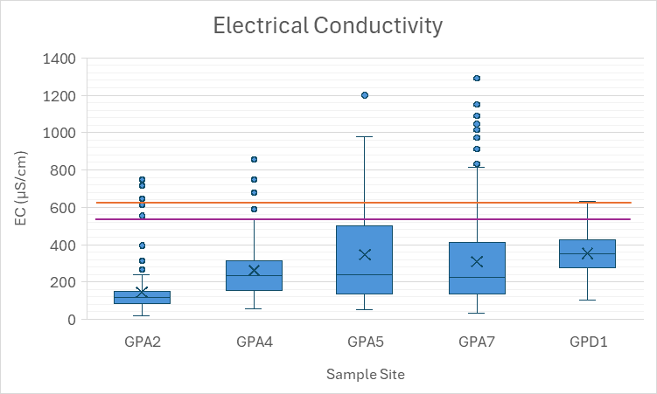
Figure 2. EC interim and long-term contaminant limits and trigger level compared to historical adjacent and downstream site data (>2m³/s flows) boxplots
The boxplots in Figure 2 show that the proposed published EC contaminant limits and long-term trigger level are within the range of concentrations previously recorded at CCM. The interim EC contaminant limit (630 µS/cm) will be used as a cease release trigger at GPA4 and GPD2 during the interim period. The cease release trigger is below the 95th percentile of pooled adjacent site data (704 µS/cm) (Table 5) and sits neatly below the upper whisker for GPD1. As seen in Figure 3 and Figure 4, the proposed trigger was exceeded at GPA2 (upstream of the release point), GPA4 and GPD1 during the 2024/25 wet season, however GPA4 exceedances have no apparent relationship to exceedances at GPD1. This indicates that future releases under the amended EA will occasionally be ceased due to GPA4 elevated EC that is not experienced at GPD1. The long-term trigger level (550 µS/cm) provides for a more conservative value to assess longer-term trends of the receiving environment and is comparable to or below the 95th percentiles of all receiving water sites (528-875 µS/cm) (Table 5).
Table 5. Historical EC data summary (>2m³/s flows)
Statistic | Electrical Conductivity (µS/cm)
Statistic | GPA2 | GPA4 | GPA5 | GPA7 | GPD1 | All sites
Number of data points (n) | 227 | 104 | 80 | 226 | 29 | 666
20th percentile | 80 | 144 | 133 | 130 | 270 | 106
50th percentile | 119 | 235 | 238 | 224 | 353 | 163
80th percentile | 156 | 328 | 572 | 471 | 431 | 358
95th percentile | 236 | 528 | 875 | 747 | 577 | 704
Proposed EC trigger level | 550
Proposed EC interim/long-term contaminant limit | 630
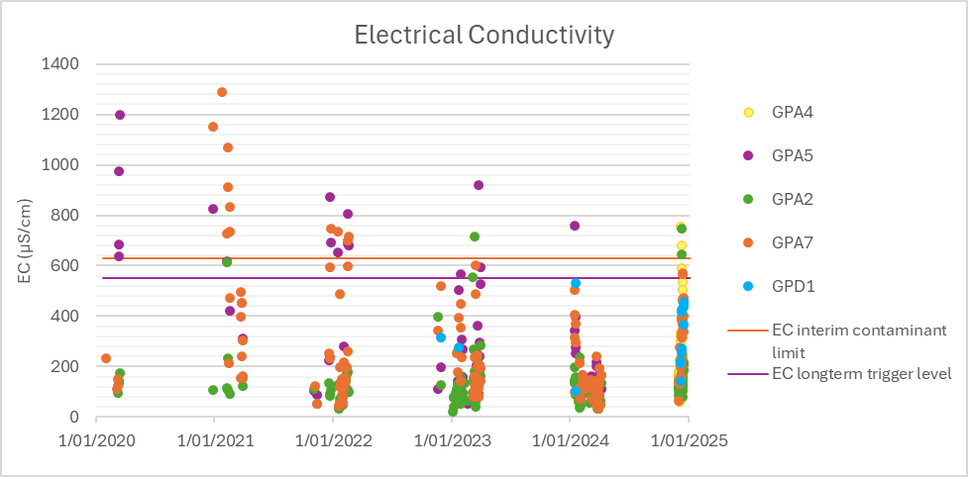
Figure 3. EC interim and long-term contaminant limits and trigger level compared to historical adjacent and downstream site data (>2m³/s flows) over time
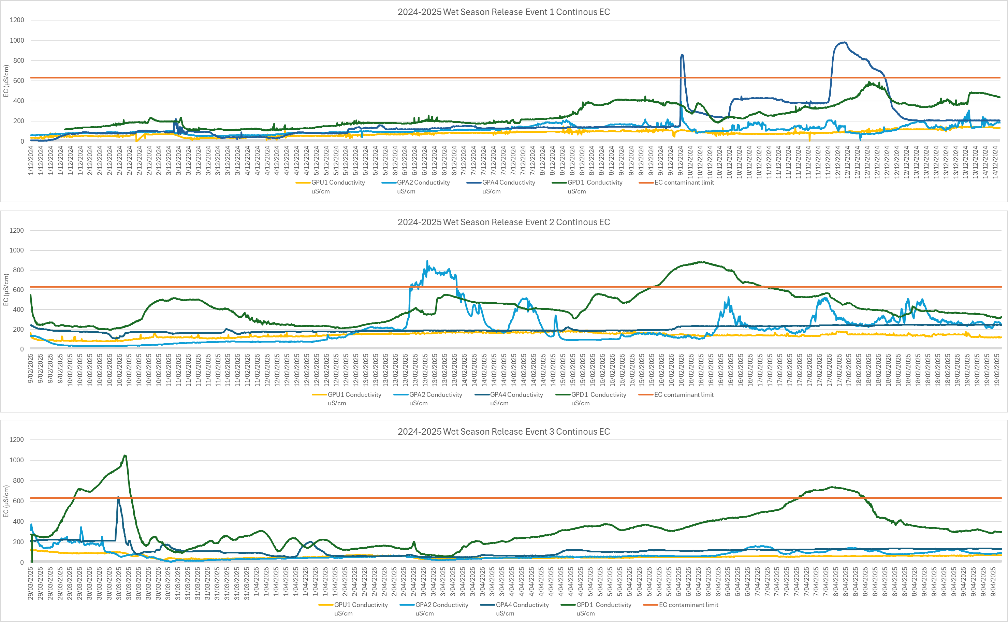
Figure 4. Continuous EC measurements during 2024/25 Wet Season Release Event 1, Release Event 2 and Release Event 3
    - Sulphate
Whilst a sulphate contaminant limit has not been set, it is useful to note that sulphate levels are generally decreasing since 2021 and that the risk of impact to the livestock EV of Gunpowder Creek is reducing. The historic data shows that Gunpowder Creek generally sits below the sulphate livestock DGV of 500 mg/L (Figure 5) with a decreasing trend in concentration since GPA5 and GPA7 exceedances in 2020 and 2021 (Figure 6). The 95th percentiles of site data (148-366 mg/L) are well below the livestock DGV (Table 6).
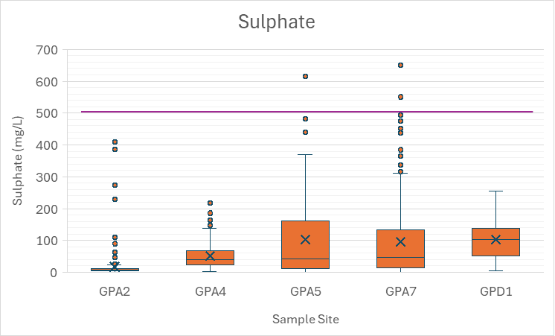
Figure 5. Sulphate default livestock (cattle) protection limit compared to historical adjacent and downstream site data (>2m³/s flows) boxplots
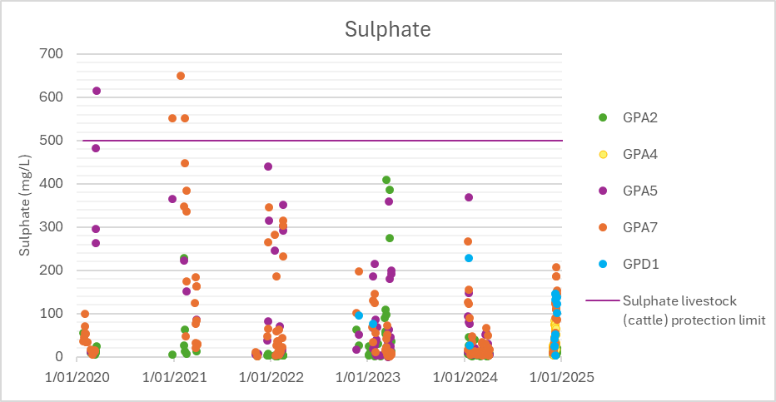
Figure 6. Sulphate default livestock (cattle) protection limit compared to historical adjacent and downstream site data (>2m³/s flows) over time

Table 6. Historical sulphate data summary (>2m³/s flows)
Statistic | Sulphate (mg/L)
Statistic | GPA2 | GPA4 | GPA5 | GPA7 | GPD1 | All sites
Number of data points (n) | 218 | 78 | 80 | 223 | 27 | 626
20th percentile | 4 | 22 | 7 | 11 | 52 | 7
50th percentile | 7 | 41 | 42 | 47 | 102 | 22
80th percentile | 13 | 75 | 194 | 164 | 139 | 100
95th percentile | 57 | 148 | 366 | 345 | 225 | 282
Proposed sulphate trigger level/contaminant limit | NA

    - Aluminium
The boxplots in Figure 7 reflect the low level of dissolved aluminium recorded at adjacent and downstream sites, with half of all data reported below the limit of reporting (LOR 0.01 mg/L) (Table 7). The proposed site-specific interim and long-term contaminant limits are very similar, 0.43 and 0.44 mg/L respectively, reflecting similar conditions at GPU1 and GPA2 at >2 m³/s flows. The 95th percentile of all sites (0.01-0.22 mg/L) are below the proposed site-specific contaminant limits and long-term trigger level (0.26 mg/L) (Table 7). The 2024/25 wet season recorded the lowest levels of dissolved aluminium over the last five years (Figure 8).
Table 7. Historical dissolved aluminium data summary (>2m³/s flows)
Statistic | Dissolved Aluminium (mg/L)
Statistic | GPA2 | GPA4 | GPA5 | GPA7 | GPD1 | All sites
Number of data points (n) | 136 | 13 | 68 | 142 | 7 | 366
20th percentile | 0.01 | 0.01 | 0.01 | 0.01 | 0.01 | 0.01
50th percentile | 0.01 | 0.01 | 0.01 | 0.01 | 0.01 | 0.01
80th percentile | 0.05 | 0.01 | 0.02 | 0.04 | 0.01 | 0.04
95th percentile | 0.22 | 0.01 | 0.07 | 0.21 | 0.02 | 0.16
Proposed long-term trigger level | 0.26
Proposed long-term contaminant limit | 0.43
Proposed interim contaminant limit | NA | NA | NA | NA | 0.44 | NA
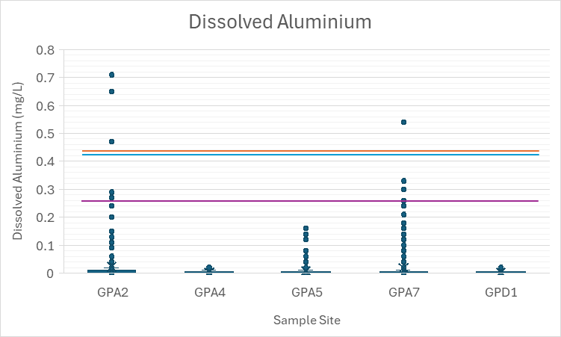
Figure 7. Dissolved aluminium interim and long-term contaminant limits and trigger level compared to historical adjacent and downstream site data (>2m3/s flows) boxplots
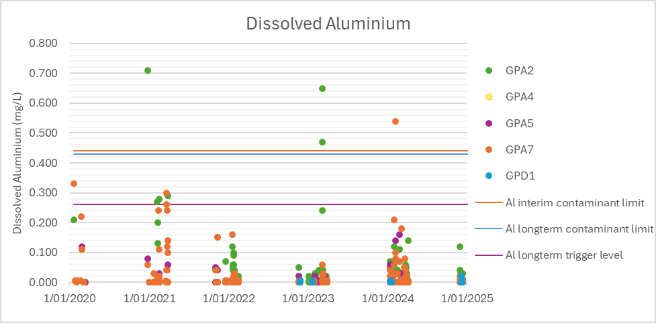
Figure 8. Dissolved aluminium interim and long-term contaminant limits and trigger level compared to historical adjacent and downstream site data (>2m3/s flows) over time
    - Cobalt
The boxplots in Figure 9 reflect the low level of dissolved cobalt recorded at adjacent and downstream sites, with the 80th percentile of GPA2, GPA4 and GPD1 site data reported below the limit of reporting (LOR 0.001 mg/L) (Table 8). The proposed site-specific and default limits/trigger are within the range of concentrations previously recorded at CCM, with the variability of dissolved cobalt at CCM over time presented in Figure 10. The proposed site-specific interim contaminant limit (0.003 mg/L) is exceeded by the 95th percentile of GPA5, GPA7 and GPD1 site data (Table 8). The proposed default QWQG long-term trigger level/contaminant limit (0.0014 mg/L) is exceeded by the 95th percentile at all sites (Table 8). Dissolved cobalt is known to be the limiting parameter for releases at CCM and some exceedances are to be expected. The conservative long-term default trigger level will facilitate continuous investigation of dissolved cobalt levels and trends to ensure that CCM activities are not allowing for a worsening and promote a transition to improvement of Gunpowder Creek water quality.
Table 8. Historical dissolved cobalt data summary (>2m³/s flows)
Statistic | Dissolved Cobalt (mg/L)
Statistic | GPA2 | GPA4 | GPA5 | GPA7 | GPD1 | All sites
Number of data points (n) | 135 | 13 | 72 | 139 | 7 | 366
20th percentile | 0.001 | 0.001 | 0.001 | 0.001 | 0.001 | 0.001
50th percentile | 0.001 | 0.001 | 0.001 | 0.001 | 0.001 | 0.001
80th percentile | 0.001 | 0.001 | 0.004 | 0.002 | 0.001 | 0.002
95th percentile | 0.002 | 0.002 | 0.015 | 0.009 | 0.004 | 0.008
Proposed long-term trigger level/contaminant limit | 0.0014
Proposed interim contaminant limit | NA | NA | NA | NA | 0.003 | NA
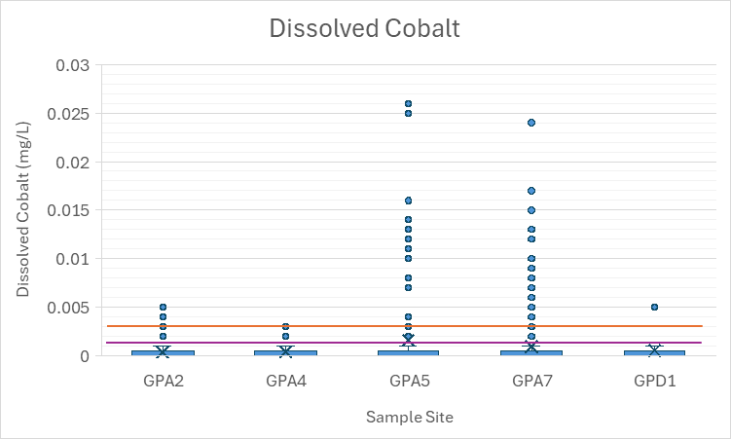
Figure 9. Dissolved cobalt interim and long-term contaminant limit/trigger level compared to historical adjacent and downstream site data (>2m3/s flows) boxplots
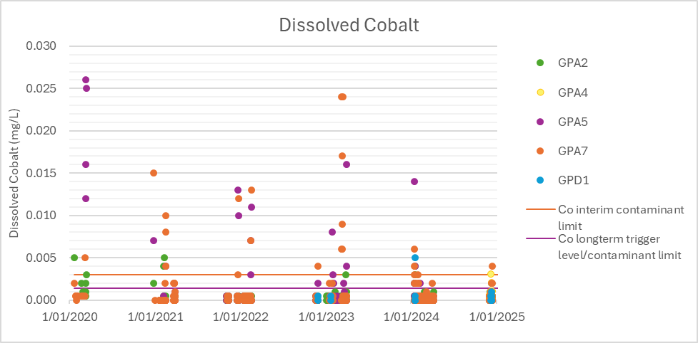
Figure 10. Dissolved cobalt interim and long-term contaminant limit/trigger level compared to historical adjacent and downstream site data (>2m3/s flows) over time
    - Copper
The boxplots in Figure 11 show that the site-specific contaminant limits and long-term trigger level are within the range of concentrations previously recorded at CCM, with the variability of dissolved copper over time presented in Figure 12. The proposed site-specific interim contaminant limit (0.014 mg/L) is exceeded by the 95th percentile of pooled site data and is equal to the 95th percentile of GPD1 site data (Table 9). The proposed site-specific long-term trigger level (0.006 mg/L) is exceeded by the 50th percentile of GPA4, GPA7 and GPD1 site data (Table 9). The proposed site-specific long-term contaminant limit (0.009 mg/L) is exceeded by the 80th percentile of GPA4, GPA5 and GPA7 site data (Table 9). Dissolved copper is also known to be a limiting parameter for releases at CCM and some exceedances are to be expected. As with cobalt, the conservative long-term default trigger level will facilitate continuous investigation of dissolved copper levels and trends to ensure that CCM activities are not allowing for a worsening and promote transition to improvement of Gunpowder Creek water quality.
Table 9. Historical dissolved copper data summary (>2m³/s flows)
Statistic | Dissolved Copper (mg/L)
Statistic | GPA2 | GPA4 | GPA5 | GPA7 | GPD1 | All sites
Number of data points (n) | 135 | 13 | 72 | 138 | 7 | 365
20th percentile | 0.001 | 0.005 | 0.002 | 0.003 | 0.006 | 0.002
50th percentile | 0.002 | 0.007 | 0.003 | 0.007 | 0.007 | 0.004
80th percentile | 0.004 | 0.011 | 0.012 | 0.013 | 0.008 | 0.010
95th percentile | 0.009 | 0.013 | 0.024 | 0.022 | 0.014 | 0.019
Proposed long-term trigger level | 0.006
Proposed long-term contaminant limit | 0.009
Proposed interim contaminant limit | NA | NA | NA | NA | 0.014 | NA
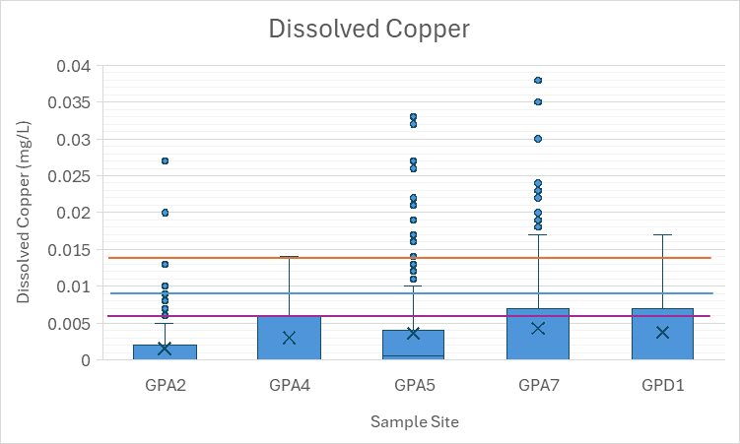
Figure 11. Dissolved copper interim and long-term contaminant limits and trigger level compared to historical adjacent and downstream site data (>2m3/s flows) boxplots
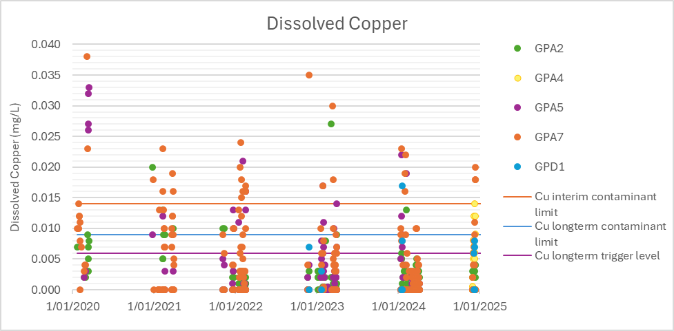
Figure 12. Dissolved copper interim and long-term contaminant limits and trigger level compared to historical adjacent and downstream site data (>2m3/s flows) over time
    - Uranium
The GPU1 and GPA2 site-specific interim contaminant limit of 0.001 mg/L is a result of a data produced by laboratory analysis at a limit of reporting (LOR) of 0.001 mg/L. A footnote has been included to EA Schedule C - Table 4 to ensure data is collected at a suitable LOR (0.0005 mg/L or less) during the interim period to enable accurate calculation of a site-specific trigger level and contaminant limit for the long-term period. CCPL have already updated their contract/quote with ALS to enact the analysis of uranium to ultra-trace levels.
    - Zinc
The boxplots in Figure 13 reflect the low level of dissolved zinc recorded at adjacent and downstream sites, with 80% of GPA2, GPA5 and GPD1 site data and over half of GPA4 and GPA7 site data reported below the limit of reporting (LOR 0.005 mg/L) (Table 10). The proposed site-specific interim and long-term contaminant limit (0.044 mg/L) is generally higher than historical concentrations recorded at adjacent and downstream sites (Figure 14) however is reflective of upstream Gunpowder Creek conditions unimpacted by CCM. The proposed site-specific long-term trigger level (0.009 mg/L) is exceeded by the 95th percentiles of GPA2, GPA4, GPA7 and GPD1 site data and below the 80th percentile of all adjacent and downstream sites (Table 10).
Table 10. Historical dissolved zinc data summary (>2m³/s flows)
Statistic | Dissolved Zinc (mg/L)
Statistic | GPA2 | GPA4 | GPA5 | GPA7 | GPD1 | All sites
Number of data points (n) | 139 | 13 | 72 | 144 | 7 | 375
20th percentile | 0.005 | 0.005 | 0.005 | 0.005 | 0.005 | 0.005
50th percentile | 0.005 | 0.005 | 0.005 | 0.005 | 0.005 | 0.005
80th percentile | 0.005 | 0.007 | 0.005 | 0.008 | 0.005 | 0.006
95th percentile | 0.018 | 0.014 | 0.008 | 0.021 | 0.012 | 0.018
Proposed long-term trigger level | 0.009
Proposed interim/long-term contaminant limit | 0.044
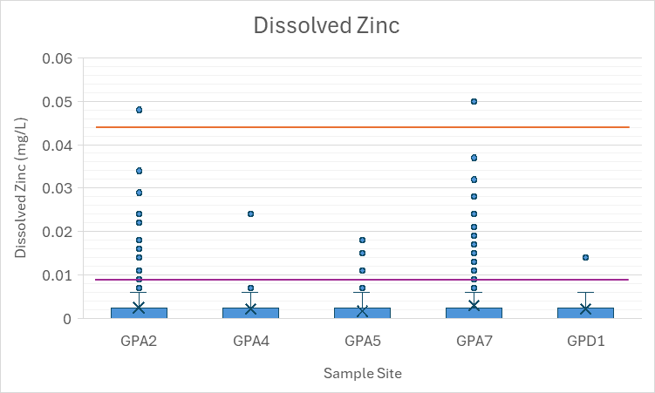
Figure 13. Dissolved zinc interim/long-term contaminant limit and trigger level compared to historical adjacent and downstream site data (>2m3/s flows) boxplots
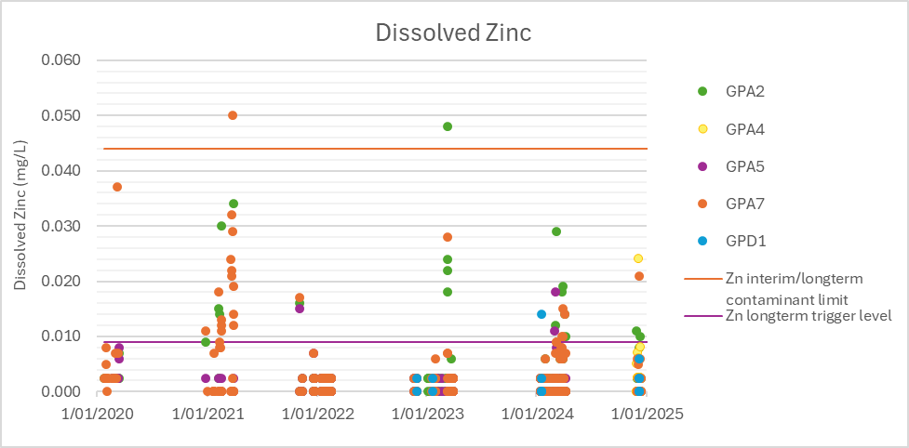
Figure 14. Dissolved zinc interim/long-term contaminant limit and trigger level compared to historical adjacent and downstream site data (>2m3/s flows) over time

Release of treated MAW: Quality and Conditions

Since submission of the initial EA Amendment application, CCPL have been operating and collecting water quality data from the temporary WTP and associated storages (November 2024 – March 2025). CCPL have used this data to derive new, achievable contaminant release limits. This section outlines the new limits and associated dilution modelling.
Following the determination of receiving environment contaminant limits as guided by DETSI’s draft EA framework, proposed release limits were input to CCPL dilution modelling to calculate minimum release rates in response to background Gunpowder Creek flows (dilution factors) required to meet downstream receiving environment water quality contaminant limits.

Treated water contaminant release limits
Proposed contaminant release limits are provided in Table 11. Total metal contaminant release limits were included following the recommendation from DETSI during the DETSI/CCPL technical workshop.
Table 11. Contaminant Release Limits
Parameter¹ | Contaminant release limit (maximum release limit unless specified otherwise) |  | Current EA
Parameter¹ | <100 m³/s background flow | >100 m³/s background flow | Current EA
Parameter¹ | Dilution rate 1:20ª | Dilution rate 1:80^{b} | Dilution rate 1:10
pH (pH units) | Must be between the range of 6.5 to 9.0 |  | 6.0 to 8.5
Electrical conductivity (µs/cm) | 5,325 | 10,256 | For indicative purposes only
Dissolved oxygen (mg/L) | Must be greater than 2 |  | >2
Sulphate (mg/L) | 4,500 | 9,000 | 3,500
Suspended Solids (mg/L) | 50 | 60 | 30 or 10% above reference
Dissolved arsenic (mg/L) | 0.03 |  | 0.25
Total arsenic (mg/L) | 0.03
Dissolved cobalt (mg/L) | 0.19 | 0.33 | 5
Total cobalt (mg/L) | 0.47
Dissolved copper (mg/L) | 0.25 | 1 | 2.5
Total copper (mg/L) | 1.7
Dissolved lead (mg/L) | 0.01 |  | 0.05
Total lead (mg/L) | 0.01
Dissolved zinc (mg/L) | 0.09 |  | 10
Total zinc (mg/L) | 0.11
Oil & grease | No detectable film or odour |  | No detectable film or odour
Minimum background creek flow (m³/s) | 2 | 100 | 1.1
1. Metals and metalloids must be measured and reported as both total (unfiltered) and dissolved (field filtered) levels.
a. Water to be released at a dilution factor of 1:20 (maximum 1 part release flow rate to 20 parts background flow rate).
b. Water to be released at a dilution factor of 1:80 (maximum 1 part release flow rate to 80 parts background flow rate).
The following should be noted:
- Even though CCPL have internal pH targets for site water management and treatment via the temporary WTP, the proposed release pH limits are simplified to 6.5 – 9.0 to allow for future improvements of water treatment onsite.
- All dilution factors are significantly higher than that required in the current EA (1:10), reducing the risk of potential impacts on the environment.
- The allowable dissolved metal limits are significantly lower than the current EA limits. This further reduces the risk of potential impact on the environment.
    - Dissolved metal contaminant release limits
Previous dilution modelling has shown dissolved cobalt, and to a lesser degree dissolved copper, to be limiting parameters (highest number of modelled exceedances) in determining the maximum release rate, relative to background flow (dilution rate). CCPL used the dilution model to show that in order to maintain a reasonable dilution rate of 1 part release water to 20 parts background creek flow, a release concentration limit of only 0.06 mg/L cobalt would need to be applied in order to meet the receiving water contaminant limit of 0.003 mg/L dissolved cobalt. Dilution modelling shows that any increase to the dissolved cobalt release limit above 0.06 mg/L would need to be matched by a decrease in release rate, relative to background flows (dilution rate), and may significantly reduce the volume of water that can be released in any given wet season. However, as evidenced in Section 6.3.2, the 2024/25 wet season water quality data show that this predicted release limit is extremely conservative. The maximum concentration of dissolved cobalt released from W1 in 2024/25 was 0.24 mg/L, with a 95th percentile of 0.19 mg/L dissolved cobalt (Table 13). Despite these release concentrations being much higher than the modelled release limit (0.06 mg/L), there was only one exceedance of dissolved copper in the receiving environment (GPD1, 0.004 mg/L dissolved cobalt). Based on this evidence, CCPL have elected to set a contaminant release limit of 0.19 mg/L dissolved cobalt, which represents the 95th percentile of 2024/25 W1 release water and the 92nd percentile of the 2024/25 WTP water quality results.
W1 dissolved copper releases of up to 0.29 mg/L, with a 95th percentile of 0.23 mg/L, resulted in exceedances of the receiving water contaminant limit of 0.014 mg/L dissolved copper at all adjacent receiving water sites, but not at downstream compliance site GPD1. CCPL have elected to set a contaminant release limit of 0.25 mg/L dissolved copper, which represents the maximum concentration of dissolved copper attained by the WTP during the 2024/25 wet season. The dilution model predicts that a release limit of 0.25 mg/L dissolved copper, released at 1:20 dilution (1 part release water to 20 parts background creek flow) would meet the receiving water contaminant limit of 0.014 mg/L dissolved copper (Section 6.2).
CCPL were able to build conservatism into the release limits of other parameters which were not found to be limiting, which have been set at the maximum concentration recorded from Pond 4 and MCD treated water quality, plus 10%.
Once Gunpowder Creek reaches flows of 100 m³/s and above a second set of release limits will apply, derived from dilution modelling at the proposed 1:80 dilution rate (Table 12) or retaining the maximum concentration recorded from 2024/25 Pond 4 and MCD treated water quality, plus 10%.
    - Sulphate contaminant release limit
During water treatment, the addition of calcium ions (from lime) results in the precipitation of sulphates as gypsum. The reaction is not driven by pH and, in general, sulphates are the major dissolved contaminant in MAW at CCM. Assessment of the measured sulphate levels in solution for all data from 2020 – 2024 for treated and untreated MAW on site confirmed the insensitivity to pH.
Previous wet seasons have seen many missed release opportunities due to treated water not achieving the current EA Contaminant Release Limit for sulphates of 3,500 mg/L. This has reduced CCM’s ability to reduce inventory on site. CCPL have elected for sulphate contaminant release limits of 4,500 and 9,000 mg/L which are reasonably attainable via the current water treatment process. Whilst the limits are higher than the current EA limit, it should be noted that the new release rate will be half the current allowable release rate in Gunpowder Creek flows less than 100 m³/s, and 1/8 of the current allowable release rate in Gunpowder Creek flows greater than 100 m³/s, and have been shown to pose a low risk of exceeding of the receiving water contaminant limit in dilution modelling, and as evidenced through 2024/25 wet season releases under the EEO.
    - Total suspended solids contaminant release limit
As per dissolved metals and sulphates, it stands to reason that the allowable total suspended solids (TSS) release limits should increase with dilution. Moreover, the updated water management system (outlined in Section 7), which sees the implementation of a clarifier (with flocculant addition) in the temporary PPWTP (and later in the permanent WTP), followed by additional residence time spent in settling ponds 3 and 4 prior to release, will significantly improve the probability of TSS being below target levels (noting some variation is inevitable).
    - Electrical conductivity contaminant release limit
As mentioned in Section 6.1.2, the very high dilution requirements mean that the chance of sulphate exceeding the proposed contaminant limit is very low. Moreover, sulphates represent the major constituent in treated and untreated MAW and is thus the major driver of electrical conductivity (EC) measurements. For this reason, EC measurements are an indicative (but not always precise) measurement of sulphates in solution. This is illustrated in Figure 15 which show all 2023 – 2024 treated and untreated MAW sampling data and indicate strong positive correlations.
The current EA sets limits for sulphate levels, with EC being used for indicative purposes only.
EC (unlike sulphate) can be measured in real-time, although EC is only an indication of sulphate levels and is affected by other metals or salts, many of which are not of interest or included in the EA limits (as noted in the variability observed in Figure 15). As such, a higher than usual EC does not necessarily equate to elevated sulphate levels but does suggest something in the system has changed and further investigation is warranted, and there have been several examples on site where EC readings were elevated, but pH, sulphate levels, and all dissolved metals of interest were not elevated. Given this, CCPL have previously proposed that EC continue to be used indicatively without a hard limit being enforced for the treated MAW release limits. However, DETSI expressed within their draft EA framework that an EC release limit was required. CCPL have accepted this request and provided EC limits of 5,325 and 10,256 µS/cm in Table 11, based on linear correlation of EC and sulphate proposed contaminant limits of 4,500 and 9,000 mg/L respectively (EC (µS/cm)=(1.0958*(sulphate mg/L))+393.31).
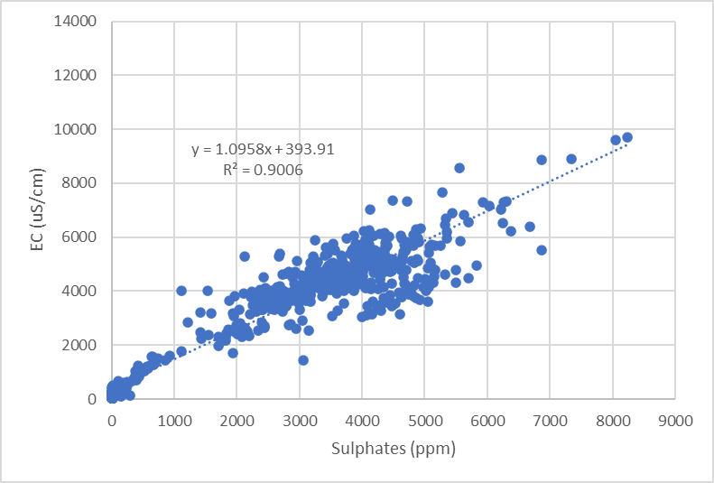
Figure 15: EC as a function sulphate assays for all untreated and treated MAW samples taken on site from 2023 – 2024

Contaminant dilution modelling
As mentioned in Section 6.1.1, the proposed treated MAW release limits were based on a combination of 2024/25 WTP water quality results and dilution modelling. The latter involved:
- Determining the reference data for upstream creek conditions. This was determined using the median of GPA2 data collected during high flows (>2 m³/s), with elevated results removed.
- Determining the “limiting contaminant” which defines the required dilution ratio for all contaminants in the receiving waters to be below their respective contaminant limits. This was found to be cobalt (and then copper) for reasons addressed in Section 6.1.1.
- Determining the minimum dilution requirement for each set of release limits based on the limiting contaminant (cobalt and copper).

The results of the updated dilution modelling are presented in Table 12. The outputs demonstrate that all proposed treated MAW release limits for dissolved As, Co, Cu, Pb, Zn and sulphate resulted in the receiving water quality being beneath the proposed receiving water contaminant limits for the determined dilution conditions. Note that an alternative dissolved cobalt release limit is presented in Sections 6.1 and 6.1.1, supported by 2024/25 release and receiving water quality data (Section 6.3.2).

Table 12. Dilution modelling outputs
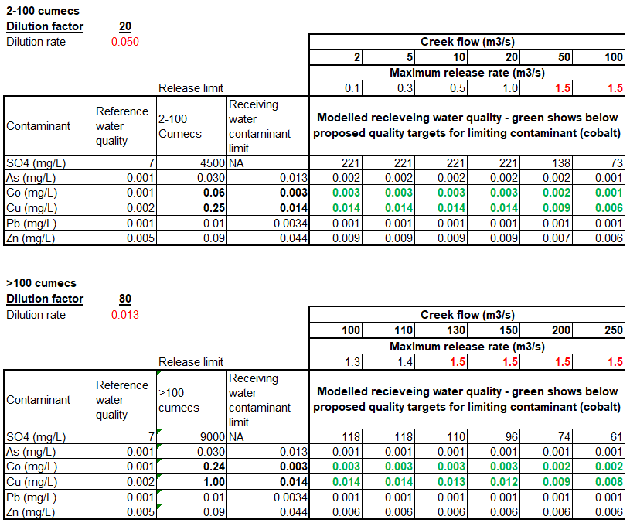

Risk assessment of proposed EA release water limits and conditions
This section presents the results of an assessment of potential impacts to the environmental values (EV) of the Gunpowder Creek receiving environment posed by the proposed amendment. The risk assessment considers the proposed release contaminant limits, dilution factors and outcomes of dilution modelling provided in Section 6.2, real data collected during the 2024/25 wet season releases under similar conditions, proposed receiving environment contaminant limits and trigger levels and other protection guideline values available for identified EVs of Gunpowder Creek.
    - Environmental Values of water
The environmental values (EVs) of Gunpowder Creek are defined as:
- Aquatic ecosystems
- Stock watering
- Secondary recreation
- Visual appreciation
- Industrial
- Cultural and spiritual values.
Default guideline values are available for aquatic ecosystems, stock watering, recreation and aesthetics, with aquatic ecosystem protection values generally the most conservative (lowest).

    - Assessment of 2024/25 release event receiving water quality
CCPL has assessed release water quality and dilution rates experienced during the 2024/25 release events and compared to the proposed release conditions in this amendment application (Table 13). In this assessment, GPD1 sample results have been applied to GPD2 proposed contaminant limits. The following observations were made:
- All water quality data recorded during the 2024/25 release events from in situ field readings, ALS laboratory results and the CCM laboratory results were used in the assessment.
- The 95th percentiles of W1 release water quality data collected on each day of release during the 2024/25 wet season are comparable to Release Contaminant Limits proposed in this amendment application, with the exception of total suspended solids. Pooling of ALS and CCM TSS laboratory results resulted in the 95th percentile exceedance of the 50 mg/L TSS proposed release limit. The impact of transportation holding times on ALS analysis results has been discussed in detail with DETSI over the 2024/25 wet season and it was agreed that CCM lab analysis provides a higher accuracy of TSS detection at the time of sample collection. For this reason, ALS TSS results were excluded from the data set and W1 TSS statistics presented in Table 13.
- Treated waters were released at a lower or comparable dilution than that proposed in this application (i.e. 1 part release water to less than or equal to 20 parts background flow) on the 11 & 13 December 2024, 13 & 15 February 2025, 29 & 30 March 2025 and 6 & 7 April 2025.
- Water will be treated through the same PPWTP during the interim period as used for the 2024/25 wet season release water treatment.
- This means that the 2024/25 wet season release event conditions are comparable to the release conditions proposed in this application and therefore 2024/25 wet season release event receiving environment results are suitable as an indicator of potential receiving environment water quality under the proposed release conditions. Further to the dilution modelling provided in Section 6.2, the 2024/25 wet season water quality results have been used to support the risk assessment of impacts to the receiving environment EVs from the proposed amendment.
Table 13. 2024/25 release water quality summary
Parameter (mg/L unless otherwise stated) | Proposed contaminant release limit | 2024/25 release water quality (W1)
Parameter (mg/L unless otherwise stated) | Proposed contaminant release limit | 95th percentile | Maximum
pH (pH units) | 6.5-9.0 | 8.8 | 9.0
Electrical Conductivity (µS/cm) | 5,325 | 4,918 | 5,210
Dissolved Oxygen | >2 | 9 | 9
Sulphate | 4,500 | 3672 | 5061
Suspended Solids | 50 | 22 | 30
Arsenic - Dissolved | 0.03 | 0.026 | 0.04
Cobalt - Dissolved | 0.19 | 0.19 | 0.24
Copper - Dissolved | 0.25 | 0.23 | 0.29
Lead - Dissolved | 0.01 | 0.01 | 0.01
Zinc - Dissolved | 0.09 | 0.03 | 0.09

CCPL has assessed receiving water quality during the 2024/25 release events and compared to the proposed receiving environment contaminant limits in this amendment application (Table 14). The following observations were made:
- GPA7 monitoring site reported higher contaminant concentrations than other adjacent or downstream monitoring sites and is likely reflecting mining-related impacts independent to the release of treated water. Therefore, GPA7 results have been excluded from this assessment.
- EC daily samples exceeded the proposed EC contaminant limit of 630 µS/cm on seven occasions during the 2024/25 wet season: twice at GPA2, four times at GPA4 and once at GPD1 (Figure 16). Continuous monitoring stations recorded eight EC exceedance events during the three release events: two at GPA2, three GPA4 and three at GPD1. Only one of the exceedance events exceeded the EEO WQO of 1,000 µS/cm, at GPD1 (Figure 4).
- Dissolved cadmium exceeded the proposed receiving environment contaminant limit of 0.0002 mg/L on three occasions during the 2024/25 wet season (0.0005-0.0007 mg/L). All three exceedances were reported from the same sampling event and can be attributed to elevated concentrations of cadmium entering the system from upstream of the release point (GPU1, 0.0006 mg/L; GPA2, 0.0007 mg/L). These exceedances do not indicate potential impact from the 2024/25 wet season releases.
- Dissolved cobalt exceeded the proposed receiving environment contaminant limit on one occasion (GPD1, 0.004 mg/L), with no exceedances reported at sites adjacent to the mine (Figure 17). Release waters contained a higher concentration of dissolved cobalt during the 2024/25 release events (95th percentile of W1 data 0.19 mg/L cobalt) compared to the cobalt release limit predicted by dilution modelling (0.06 mg/L) to meet the proposed dissolved cobalt receiving water contaminant limit of 0.003 mg/L. For this reason, the modelled release limit is considered overly conservative and CCPL have elected to propose a contaminant release limit of 0.19 mg/L dissolved cobalt (Section 6.1.1).
- Dissolved copper exceeded the proposed receiving water contaminant limit on ten occasions and included exceedances at all adjacent monitoring sites (GPA) but not at downstream site GPD1.
- All analysis results for pH, dissolved arsenic, chromium, copper, lead and zinc were below the proposed receiving water contaminant limits at compliance site GPD1 on all occasions.
- All 95th percentiles of adjacent sites GPA2, GPA4, and GPA5 pH, dissolved arsenic, cadmium, chromium, copper, lead and zinc results were below the proposed receiving water contaminant limits.
- Assuming seepage intervention improvements result in improving water quality in Gunpowder Creek over the coming years, releases undertaken in accordance with proposed interim and long-term contaminant release limits and dilution ratios are not expected to impact the aquatic ecology EV of Gunpowder Creek in the interim or into the future.
Table 14. 2024/25 release event receiving water quality summary
Parameter (mg/L unless otherwise stated) | Proposed receiving environment contaminant limit (>2 m³/s) | 2024/25 release event pooled adjacent site (GPA) data |  | 2024/25 release event GPD1 data
Parameter (mg/L unless otherwise stated) | Proposed receiving environment contaminant limit (>2 m³/s) | 95th percentile | Maximum | 95th percentile | Maximum
pH (pH units) | 6.5-8.5 | 7.6 | 8.0 | 8.0 | 8.1
Electrical Conductivity (µS/cm) | 630 | 502 | 855 | 599 | 633
Arsenic - Dissolved | 0.013 | 0.013 | 0.018 | 0.013 | 0.013
Cadmium - Dissolved | 0.0002 | 0.0002 | 0.0007 | 0.0005 | 0.0006
Chromium - Dissolved | 0.001 | 0.001 | 0.001 | 0.0008 | 0.001
Cobalt - Dissolved | 0.003 | 0.003 | 0.003 | 0.0034 | 0.004
Copper - Dissolved | 0.014 | 0.015 | 0.023 | 0.014 | 0.014
Lead - Dissolved | 0.0034 | <0.0001 | 0.003 | 0.0015 | 0.003
Zinc - Dissolved | 0.044 | 0.024 | 0.038 | 0.021 | 0.028

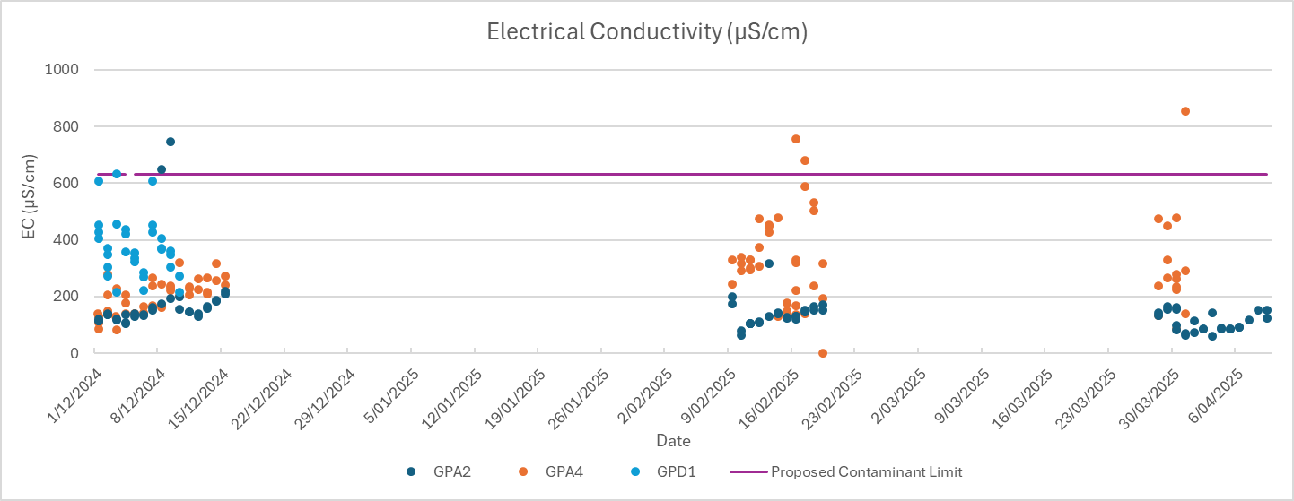
Figure 16. Electrical conductivity at adjacent and downstream receiving environment monitoring sites during the 2024/25 wet season release events
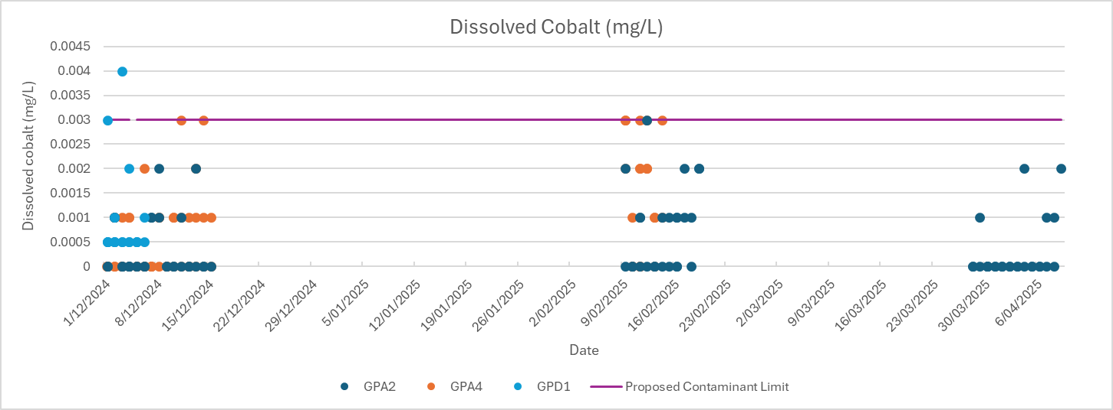

Figure 17. Dissolved cobalt at adjacent and downstream receiving environment monitoring sites during the 2024/25 wet season release events
    - Risks to other EVs - total metal concentrations
Whilst proposed contaminant release limits and receiving environment contaminant limits are based on dissolved metals which supports the protection of aquatic ecosystem EV, assessment of the potential risk to other relevant EVs must also be considered. CCPL have assessed release water quality dissolved and associated total metal concentrations experienced during the 2024/25 release events and compared to available guideline values relevant to the EVs of Gunpowder Creek (Table 15). The following observations were made:
- Note that available livestock, recreational and aesthetic EV water quality guidelines are based on total metals, with livestock values being lower than recreation and aesthetic. Therefore, protection of livestock EV will by default also protect recreation and aesthetic EVs.
- Despite the very high TSS concentrations reported by ALS, the 95th percentiles of W1 release water quality data collected on each day of release during the 2024/25 wet season are below the default ANZG stock (cattle) watering limits for pH, EC and total metals.
- Sulphate is the only 95th percentile release water quality parameter to exceed the livestock limit, at 3,672 mg/L sulphate (well above the stock limit of 500 mg/L).
- Maximum release water quality results only slightly exceeded total arsenic and total copper stock limits, with all other parameters except sulphate below stock limits.
- Whilst sulphate levels are much higher than the stock limit in the release water, the application of a high dilution factor will ensure that exceedances of the sulphate stock limit are not experienced downstream in the receiving environment (as shown in Section 6.2 dilution modelling).
- Based on these findings alone, it is unlikely that releases undertaken in accordance with the conditions proposed in this application (e.g. high dilution) will result in parameters exceeding stock watering limits in the receiving environment.
- The risk of impacts to livestock, recreation or aesthetic EVs is very low.
Table 15. 2024/25 release water quality risk to livestock
Parameter (mg/L unless otherwise stated) | Proposed contaminant release limit | Stock watering limit | 2024/25 release water quality (W1)
Parameter (mg/L unless otherwise stated) | Proposed contaminant release limit | Stock watering limit | 95th percentile | Maximum
pH (pH units) | 6.5-9 | 4-9 | 8.8 | 9.0
Electrical Conductivity (µS/cm) | 5,325 | 5970 | 4918 | 5210
Dissolved Oxygen | >2 | - | 9 | 9
Sulphate | 4500 | 500 | 3672 | 5061
Suspended Solids | 50 | - | 1238 | 1580
Arsenic - Dissolved | 0.03 | - | 0.026 | 0.04
Arsenic - Total | 0.033 | 0.025 | 0.020 | 0.03
Cadmium - Total | - | 0.01 | 0.001 | 0.0033
Chromium - Total | - | 0.05 | 0.0032 | 0.006
Cobalt - Dissolved | 0.19 | - | 0.19 | 0.24
Cobalt - Total | 0.47 | 1 | 0.27 | 0.33
Copper - Dissolved | 0.28 | - | 0.23 | 0.29
Copper - Total | 1.7 | 1 | 0.97 | 1.16
Lead - Dissolved | 0.011 | - | 0.01 | 0.01
Lead - Total | 0.011 | 0.1 | 0.01 | 0.01
Zinc - Dissolved | 0.01 | - | 0.03 | 0.09
Zinc - Total | 0.11 | 20 | 0.05 | 0.10
CCPL has assessed receiving water quality experienced during the 2024/5 release events and compared to available guideline values relevant to the livestock, recreation and aesthetic EVs of Gunpowder Creek (Table 16). The following observations were made:
- Note that available livestock, recreational and aesthetic EV water quality guidelines are based on total metals, with livestock values being lower than recreation and aesthetic. Therefore, protection of livestock EV will by default also protect recreation and aesthetic EVs.
- GPA7 monitoring site reported higher contaminant concentrations than other adjacent or downstream monitoring sites and is likely reflecting mining-related impacts independent to the release of treated water. Therefore, GPA7 results have been excluded from this assessment.
- 2024/25 wet season release event receiving environment water quality was below livestock stock limits at all sites on all occasions for all parameters.
- No impact to livestock, recreation and aesthetic EVs was detected from the 2024/25 wet season releases under the EEO and EA. Given the dilution factors are higher and dissolved metal release limits are lower in this proposed amendment than in the EEO or current EA in place at the time of the 2024/25 wet season releases, the risk of impacts to livestock, recreation or aesthetic EVs as proposed in this amendment is considered low.
Table 16. 2024/25 release event receiving water quality risk to livestock
Parameter (mg/L unless otherwise stated) | Stock watering limit | 2024/25 release event pooled adjacent site (GPA) data |  | 2024/25 release event GPD1 data
Parameter (mg/L unless otherwise stated) | Stock watering limit | 95th percentile | Maximum | 95th percentile | Maximum
pH (pH units) | 4-9 | 7.6 | 8.0 | 8.0 | 8.1
Electrical Conductivity (µS/cm) | 5970 | 502 | 855 | 599 | 633
Sulphate | 500 | 132 | 286 | 219 | 256
Arsenic - Total | 0.025 | 0.020 | 0.024 | 0.022 | 0.025
Cadmium - Total | 0.01 | 0.0005 | 0.0014 | 0.0005 | 0.0006
Chromium - Total | 0.05 | 0.005 | 0.010 | 0.002 | 0.002
Cobalt - Total | 1 | 0.007 | 0.016 | 0.005 | 0.005
Copper - Total | 1 | 0.029 | 0.137 | 0.024 | 0.025
Lead - Total | 0.1 | 0.004 | 0.006 | 0.006 | 0.007
Zinc - Total | 20 | 0.020 | 0.042 | 0.027 | 0.043

CCM Water Management System
Sections 4, 5 and 6 have presented the proposed limits and conditions for release of water from CCM into Gunpowder Creek. This chapter focuses on:
- Strategy
- Site infrastructure and systems
- Compliance.

Strategy – treatment and release
In addition to recycling and evaporation, the treatment and release of MAW is a key control for ensuring MAW does not accumulate onsite across multiple wet seasons or during extreme events, increasing the risk of uncontrolled release and resultant environmental harm to the receiving environment. This method of managing water inventory is used by several other mining sites in the region and can have minimal impacts on the environment when completed in accordance with carefully selected parameters that ensure environmental protections. A number of potential release options have been assessed, including the opportunity to undertake controlled releases of treated MAW from CCM to Gunpowder Creek during various wet season scenarios. Refer to Appendix B – Engeny (2023) Release Assessment. Whilst the immediate objective is to remove the water inventory resulting from the March 2023 event and the subsequent 2023/24 wet season, this EA Amendment is critical to the long-term sustainable management of MAW at CCM.
Current (up to date as of October 2025) and proposed water management improvements at CCM include:
- Cessation of water intake from Lake Waggaboonya for mining and mineral processing, through increased recycling of MAW from EPit and MCD.
- Significant increase of mechanically enhanced evaporative throughput capacity.
- Installation of a bulk MAW treatment and release system in the MCD prior to the 2024/2025 wet season.
- Full refurbishment and upgrade of lime slaking plant prior to the 2024/2025 wet season.
- Upgrade and replacement of online creek and release monitoring system to allow for higher frequency measurement and improved reliability.
- Conversion of processing plant to a temporary WTP (PPWTP) during suspension of operations prior to the 2024/2025 wet season, with further upgrades to treat and release (via Pond 4) of rates in excess of 22ML/day.
- Installation and operation of a permanent, large-scale, WTP as an agreed condition of approval and construction of TSF3.
A simplified site flowsheet for the current (and long-term) water treatment and release systems is provided in Figure 18.
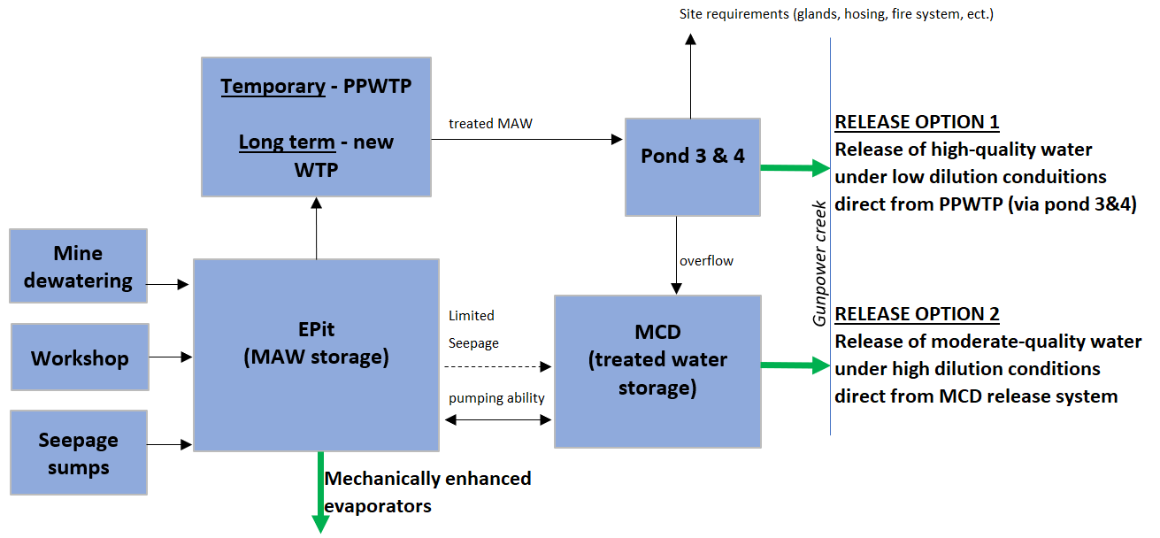
Figure 18: CCM site flowsheet for water treatment and release systems
The EPit will continue to act as the central storage for MAW on site, with all mine dewatering and seepage sumps being directed to the EPit. It is noted that there is a seepage pathway from the EPit to the MCD when EPit levels exceed a RL of 225m AHD. The mechanically enhanced evaporator systems located at the EPit will continue to remove MAW from site throughout the year.
MAW will be pumped to the PPWTP from the EPit or MCD, treated, and then sent to ponds 3 and 4. The capacity of this system (as of Oct 2025) is 22-25 ML/day. This will later be replaced by the new (permanent) WTP which will have increased capacity as a condition of an approved and constructed TSF3.
From ponds 3 and 4, freshly treated, high-quality water can be released under controlled conditions to the creek as creek flowrates allow. This release option would be the primary method of release in the upcoming 2025/2026 wet season, as it ensures high quality treated water. Water not released overflows to and is stored in the MCD.

The treatment and release of MAW from the MCD was the primary water treatment strategy in the 2024/2025 wet season. However, this option requires large amounts of lime, creates a lot of sludge that occupies volume within the MCD and resulted in variable water chemistry due to the MCD not being perfectly mixed. Nevertheless, the MCD still has the ability to lime treat water in-situ and release to the creek if the chemistry and/or dilution in the creek allows.
This flowsheet allows for flexibility and redundancy, with a view to maximising release opportunities during wet seasons.

Site infrastructure and systems
    - Recycling of MAW
Following the March 2023 extreme wet season event, CCM ceased all water intake from Lake Waggaboonya for mining and mineral processing requirements. As the existing WTP was inundated by the rising waters, a temporary facility was developed which enabled lime addition and mixing in Ponds 3 and 4 before pumping the treated water at a rate of 10-12ML/day to the repurposed raw water tank for supply of all mining and mineral processing requirements. This system was commissioned and operating by the re-start of operations on 1 August 2023. Subsequently, additional antiscalant dosing, automatic pH control and filtration systems were installed to mitigate impacts of water quality on equipment. The system was also successfully used to treat and release water during the 2023/2024 wet season.
During the 2024/2025 wet season, treated water from the PPWTP was used to supply much of the water required for processing in addition to raw water from Lake Waggaboonya. This same strategy will be used in the upcoming 2025/2026 wet season.
Prior to a restart of operations at CCM, a new fit-for-purpose built permanent WTP will be built as a condition of approval and construction of TSF3. This WTP will be designed to produce water of adequate water quality such that is can be used for all operational requirements (e.g. underground mining, ore processing, haul water dust suppression, etc.) to limit all raw water imports to a minimum.
    - Evaporators
CCPL have also purchased, installed and commissioned additional mechanical evaporative throughput capacity at the EPit. During the 2025 dry season, the six high volume evaporators have been modified to all work on electric power be fed at the correct feed pressure in the supply line. Current total throughputs (as of October 2025) are 15 ML/day.
    - Real-time water quality monitoring stations
Previously, three installed remote monitoring stations (GPU1, GPA2 and GPD1) on Gunpowder Creek used remote dataloggers to collect information from the field instruments and then transfer and store data to the online cloud storage via a satellite. To view the data from the monitoring stations, site had to login to an internet-based portal and view the data through a web page. This system has repeatedly proven to be unreliable during the wet season, as it relies on site always having internet access via a microwave radio link. This is frequently offline during bad weather or electrical storms, which is when site is likely to be considering releases to Gunpowder Creek.
Prior to the 2024/2025 wet season, a new, upgraded system including an additional location (GPA4) allowed for continuous, real time, remote monitoring of key receiving water parameters (pH, EC, and flowrate), while removing the need for a satellite uplink and internet access. This was achieved by directly linking the instrumentation data loggers to the site process control system (PCS) via a telemetry system that uses radio communication to transmit the data. The system was shown to work well and was not affected by weather or topography, allowing for the reliable transfer of data required for an automated release control system.
To ensure a reliable and continuous power supply for the remote instrumentation and data loggers (where no mains power is available), each unit has been fitted with a solar array and suitably sized battery back-up as required. This was shown to be very reliable in the 2024/2025 wet season.
The new monitoring system allows for the creek flow, pH and EC to be measured in real time, along with treated water pH and EC. This combination enabled the implementation of automated release control, whereby release is only undertaken when conditions are correct. This was shown to work well in the 2024/2025 wet season. Refer to Figure 20 for the location of monitoring stations and Section 7.3.2 for details of the automated release control process.
    - Full refurbishment and upgrade of lime slaking plant
A reliable and plentiful supply of milk of lime (slaked quick lime) is key to effective water treatment of MAW. Following suspension of operations at CCM in April 2024, a decision was made to strip and refurbish the existing lime slaking plant to ensure the plant’s performance was returned to design specifications prior to the 20204/2025 wet season. Completion of this work has resulted in greatly improved reliability of the plant as was demonstrated in the 2024/2025 wet season.

    - Temporary Water Treatment Plant
Following the suspension of operations in April 2024, design work began to temporarily convert the Processing Plant into a WTP (PPWTP). The design makes use of the rougher flotation and tailings thickener circuits. Water is pumped from the EPit or MCD and passes through the rougher flotation circuit where the pH is automatically controlled using lime addition. The roughers are also thoroughly mixed, allowing for good reaction kinetics for the precipitation of metal hydroxides and gypsum. The roughers then flow to the tailing’s thickener where flocculant is added to promote settling. The overflow (the clarified treated water product) is pumped to ponds 3 and 4. The precipitated metals and gypsum sludge will report to the tailing’s thickener underflow, and is both recycled to the head of the roughers (to allow for seeding) or deported to the Esperanza Tailings Storage Facility (ETSF) for storage along with previously deposited tailings. This ensures sludge will not occupy volume in the MCD or EPit.
During the 2024/2025 wet season, the PPWTP was designed for a throughput of 12ML/day and was shown to produce “high quality” water in line with the quality targets proposed in this application. The time spent by the product water in ponds 3 and 4 allowed for further settling of any remaining suspended solids. Standby/duty pumps on pond 4 allowed for the direct release of water from pond 4 to the creek, provided the creek flow and the treated water quality was in accordance with the EEO targets. Alternatively, water overflowed from pond 4 into the MCD, allowing for further top-up and storage of treated MAW in the MCD ahead of a release to the creek when creek flow conditions allow.
Following a successful 2024/2025 wet season, the PPWTP throughput has been upgraded to a throughput of 22-25ML/day. As of October 2025, the plant has been commissioned and is ready for operation. Due to the increased throughput, lower lime requirements, the high-quality product water, the ability to send all sludge to the ETSF and good reliability, release from Pond 4 direct to the creek will be the primary method of release from CCM during the 2025/2026 wet season.
The interim period associated with the proposed EA Amendment, nominated as 1 November 2025 to 1 November 2028, is based on continuing releases from the PPWTP (and MCD). The infrastructure required to operate and release from the PPWTP is currently in place at CCM and no new disturbances to land are required.

    - Permanent Water Treatment Plant
Design work continues for the permanent WTP for site in collaboration with Ausenco. The new WTP will have a design throughout of 15 ML/d (with allowance of 20ML/day for greater sprint capacity) and allows for all of site’s mining and processing needs (8-10ML/d) plus a surplus of 5-7 ML/d for storage in the MCD prior to the wet season for controlled release when creek flows allow. The new WTP will also be able to release water directly to the creek (via ponds 3 and 4) if required.
The design of the plant will mirror the design of the PPWTP, with the design including excess reactor residence time to allow for high quality water (with low scaling potential) to be produced. The timeline of this project is dependent on approval and construction of TSF3.
The new WTP will be constructed on existing disturbed land and no new land disturbances will be required. The new WTP will be constructed onsite to aid water reuse and recycling, and is not subject to approval of this proposed amendment.

    - MCD bulk treatment
Prior to the 2024/2025 wet season, CCPL finalised the installation of the bulk neutralisation and release system in the MCD, as shown in Figure 19.
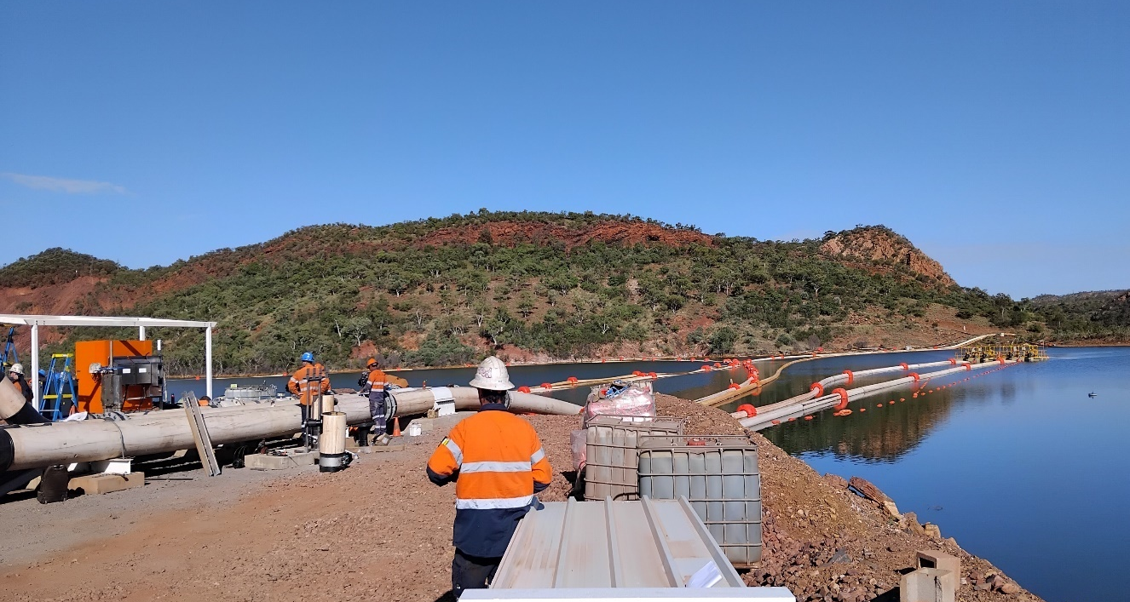
Figure 19: Completed MCD bulk treatment and release system (May 2024)
The design of this system prior to 2024/2025 wet season allowed for pre-treated water (circa 450ML) to be stored in anticipation of ideal creek flow conditions in the creek and will have a maximum release rate of 100 ML/d with three of the four release pumps running (the other pump being on standby).
The system automatically lime treats water within the MCD and can be used to ensure the contents of the MCD are held at desirable release pH levels while awaiting a release. Additionally, acidic MAW could be added from the EPit and then subsequently treated in-situ. Alternatively, the MCD will be topped up with treated water from the PPWTP (via ponds 3 and 4).
This system was proven to work well within the 2024/2025 wet season, although the system was also shown to use large amounts of lime and generate large amounts of sludge (which in turn occupied volume within the MCD). Moreover, the large unmixed MCD resulted in varying localised chemistry. As a result of this (plus the increase in PPWTP throughput), the strategy is to favour release of treated water via Pond 4 in the upcoming 2025/2026 wet season.

Compliance and management response to exceedances
During a release event, water quality exceedances of EA values will be identified from data collected at real-time creek monitoring stations and laboratory reported data. Exceedances could occur in:
- Release waters
- HD zone waters
- MD zone waters.
Each of these waters will have different water quality limits or objectives. Further to this, the speed in which the exceedance is identified will vary considerably between the real-time stations and the laboratory analysis process.
    - Laboratory analysis reported exceedance
Release water exceedances of metals/metalloids determined via laboratory analysis will be appropriately investigated and reported on a daily basis.
Receiving water exceedances of parameters determined via laboratory analysis will be compared to reference site conditions and investigated in accordance with Condition C3-2, including comparison to any event-based default guideline value adjustments (e.g. DOC-adjustment).
    - Monitoring station exceedance and automated release management
Unlike the laboratory analyses for metals and metalloids, exceedances detected at telemetry monitoring stations in the creek and release water system will be automatically reported in real time. Parameters measured at the stations will be limited to pH and EC, with the addition of flow monitoring at GPA2 immediately upstream of the release point. The parameter pH is directly indicative of metal solubility and thus the single most important parameter, making real time measurement highly beneficial in avoiding environmental harm. Actions relating to any exceedances measured by the real-time creek monitoring stations during a release, or in the event of a communications failure, are outlined below:
- State 1: Normal release operation
  - Condition: All measured process values are within CCM site defined and EA release limits/water quality objectives (WQOs).
  - Action: Creek release initiated/continued as per EA conditions.
- State 2: Water quality value alarm during release
  - Condition: One (or more) measured process values/creek monitoring station values is out of compliance with CCM defined trigger limits, but within EA limits.
  - Action:
    - Creek release continues.
    - Level alarms generated on site Process Operating System for relevant water quality values, notifying the control room that one of the critical process values is approaching the release limit/WQO.
    - Control room to initiate check of treatment system/equipment and key parameters and prepare to decrease release rate (dilution ratio) or potential shutdown.
- State 3: System trip due to non-compliance of release/creek water quality (or communications link failure)
  - Condition: One or more measured process values/creek monitoring station values is out of compliance with agreed EA limits AND/OR a communications link failure is detected.
  - Action: Automated release system trip is initiated, closing all release valves to prevent further release of water to the creek. Continue investigation of system to determine faults or errors leading to non-compliance.
- State 4: Background flow rate trip during release
  - Condition: The flow rate at monitoring station GPA2 drops below the EA minimum flow of 2 m³/second.
  - Action: Automated Release System trip is initiated, closing all release valves to prevent further release of water to the creek. Preparation of system to continue release once creek flow increases back above minimum creek flow.

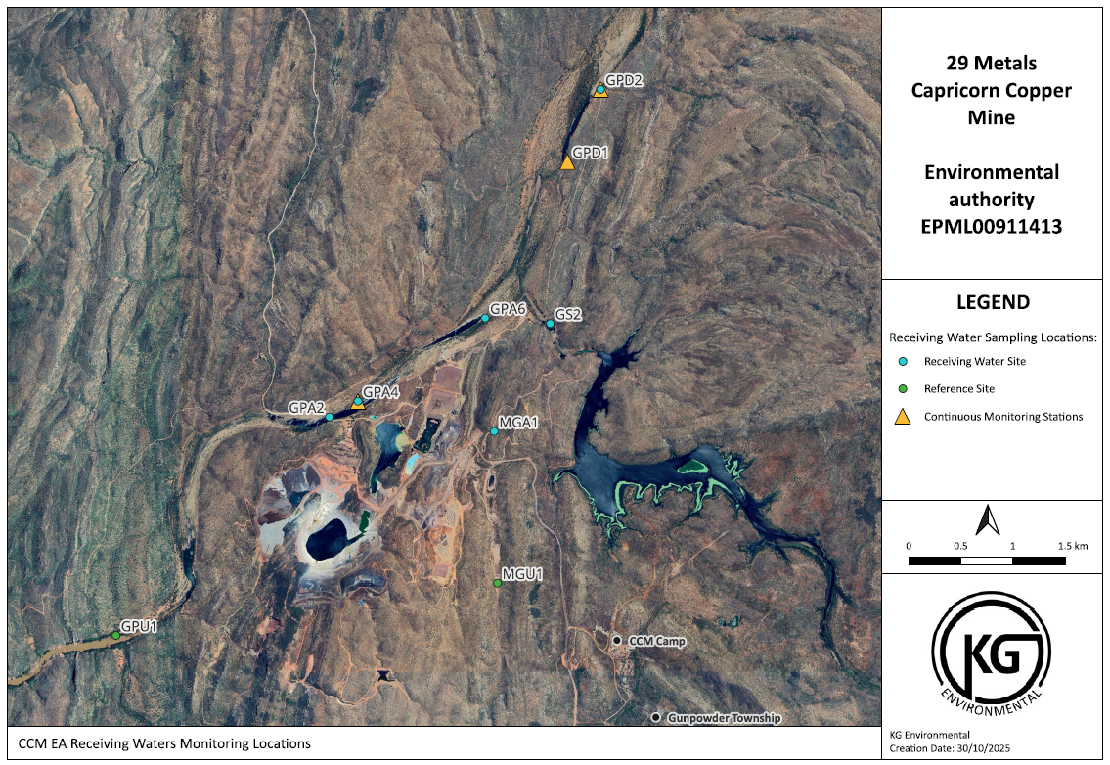
Figure 20: Real-time Creek Monitoring Stations

Environmental Values Assessment
Potential impacts from the proposed EA amendment (increased release volume and application of new contaminant limits and trigger values) are limited to the receiving environment of Gunpowder Creek and have been addressed under Section 8.3 Water. The Environmental Values (EVs) of Gunpowder Creek are listed in Section 6.3.1 and include aquatic ecosystems, stock watering, secondary recreation, visual appreciation, industrial (mining) and cultural and spiritual values. Potential risks to EVs from the proposed amendment activity will be managed by complying with the existing and proposed EA conditions and release management risk practices as outlined in Section 7.3 of this document.

Air

Description of Environmental Value
The airshed associated with CCM is typical of a rural area impacted by agricultural activities, mining and exploration activities, and transport activities on unsealed roads.
Existing potential sources of particulate emissions from the surrounding environment primarily comprise:
- mining and exploration activities
- grazing activities
- unsealed roads
- smoke.
There are no residential areas in the vicinity of CCM; the mine camp is located approximately 1 km south-east of the closest mining lease (Magazine Creek).

Emissions or releases
Particulates are released to the environment from a range of mining activities. Sources include vehicle exhaust emissions, vehicles travelling on unsealed roads, loading and unloading ore and waste into haul trucks, transfer of stockpiled ore into crushers, crushing of ore, waste rock stockpile construction, rehabilitation earthworks and wind erosion on bare earth surfaces. Emissions (carbon monoxide, carbon dioxide, sulphur oxides and nitrous oxides) are emitted from vehicle/equipment exhaust emissions, hydrocarbon storage and use of reagents.
There will be no increase to emissions or new sources of emissions to air from the proposed amendment.

Potential impacts
There are no potential impacts to air quality specific to the amendment application.

Management practices
Not applicable.

Acoustic

Description of Environmental Value
Environmental values associated with acoustic quality are typical of a rural area impacted by agricultural activities, mining and exploration activities, and transport activities on unsealed roads.

Emissions or releases
There are no sources of noise or vibration above ambient levels except for sporadic cattle movement and the operation of the mine (including transport to the mine by road and air).
There will be no increase to noise or vibration from the proposed amendment.

Potential impacts
There are no potential impacts to acoustic quality specific to the amendment application.

Management practices
Not applicable.

Water

Description of Environmental Value
A description of the EVs of the receiving environment are provided in Section 6.3.1 They include aquatic ecosystems, stock watering, secondary recreation, visual appreciation, industrial (mining) and cultural and spiritual values, pertaining to Gunpowder Creek.

Emissions or releases
Releases of contaminants via release of treated MAW are relevant to this application. Details are provided in Section 6, Section 7 and Appendix B – Engeny (2023).

Potential impacts
Potential impacts to the receiving environment from this application include the contamination of receiving waters and sediments and the degradation of aquatic ecosystems through increased contaminant concentrations and changes to hydrological regimes.
Impacts to aquatic ecosystems from changes to the hydrological regime are not expected to occur as releases will be restricted to the wet season during periods of natural flow >2 m³/s and the local ecosystems are adapted to a range of flow conditions, highly variable between years.
Whilst the current EA allows for release of contaminants in treated MAW water, the release limits set in the EA have never been linked to receiving water quality limits. CCPL are proposing to reduce release water limits in most instances and have undertaken scientific assessment of the relationships between release limits, predicted and historic receiving environment water quality and the aquatic ecosystem of Gunpowder Creek.
The risk assessment undertaken in Section 6.3 shows that proposed release and receiving environment limits and triggers are sufficiently conservative and that potential impacts to the receiving environment from releases of treated water can be effectively managed under the proposed conditions of the amended EA (Appendix A).

Pre-existing impacts
CCPL acknowledge that the mining legacy of the Capricorn Copper Mine site has resulted in ongoing sources of environmental contamination (seepages). CCPL have been upgrading site infrastructure to reduce known seepage from problematic sites such as North Waste Rock Dump and Old Mammoth TSF, as witnessed by DETSI officials during site visits.
CCPL have finalised a site-wide groundwater model after installing an additional 13 groundwater bores and are using this model to plan and undertake a comprehensive seepage and groundwater impact investigation and assessment. However, as DETSI notes in pre-lodgement correspondence, this investigation is outside of the scope of the current proposal. Therefore, groundwater assessment has not been included in this application material.

Management practices
Management practices to mitigate the risk of potential impacts to aquatic ecosystems include:
- treatment and testing of MAW to ensure contaminant concentrations are reduced to levels below the relevant contaminant release limit
- application of lower release contaminant limits as proposed in this EA amendment application
- real-time water quality monitoring for pH and EC
- real-time monitoring of Gunpowder Creek flow
- automated shut-off of the release with exceedances (upper and lower) in pH, EC or flow
- automated shut-off of release on communications fail with real-time monitoring stations
- annual REMP preparation.
See Sections 7.2 and 7.3 for further details.

Waste

Emissions or releases
There will be no waste generation from the proposed amendment.

Potential impacts
There are no potential impacts to waste specific to the amendment application.

Management practices
Not applicable.

Land

Description of Environmental Value
CCM is situated in the hilly and mountainous Mt Isa highlands with elevations ranging from 90 mAHD at Gunpowder Creek to 310 mAHD at the mine site. Slopes range from moderately inclined (average 25–27º) to steep (35º). Skeletal soils are extensive on the ridges and slopes and red earths occur on lower slopes and on alluvial terraces. The pre-mining land capability (at 1997) was Class VIII for almost all the areas, with the remining areas Class VII. Pastoral activities were carried out (in addition to mining and exploration) in the area and was largely limited to the waters of Gunpowder Creek.

Emissions or releases
There will not be any emissions or releases to land associated with the proposed amendment.

Potential impacts
There are no potential impacts to land specific to the amendment application. No new land disturbance is required for the interim release infrastructure or new permanent WTP and associate release infrastructure.

Management practices
Although there is no new disturbance associated with the proposed amendment release infrastructure, CCPL have developed rehabilitation and closure plans for existing disturbances as part of the Progressive Rehabilitation and Closure Plan (PRCP) application submitted to the department on 30 September 2025.
Rehabilitation milestones relevant to water treatment and release infrastructure are planned to include (subject to DETSI approval):
- Infrastructure decommissioning and removal
- Contaminated land investigation and remediation (MCD and Pond 4)
- Landform development (reshaping and reprofiling)
- Surface preparation (e.g. surface scarification)
- Revegetation with species relevant to the target PMLU
- Achievement of surface requirements for PMLU (e.g. rehabilitation monitoring targets)
- Achievement of PMLU to stable level (e.g. rehabilitation monitoring and water quality targets).
Disturbed areas will be rehabilitated to a post-mining land use (PMLU) of low density grazing (MCD, Pond 4, PPWTP, new WTP, pipelines) native bushland (some pipelines and access tracks) and waterways (creek monitoring stations and access tracks).
Low density grazing PMLU
CCM sits within the Southern Gulf region, as mapped by land type for grazing land management, and specifically within the Rough Spinifex Hills (RSH) unit which is described as hilly country with rocky plateaus supporting sparce low woodland of Snappy Gum. The assessment of the long-term carrying capacity of the undisturbed RSH unit, assuming a 10% foliage protective cover (FPC) for one animal equivalent (1AE - 450kg beast consuming 8kg of dry matter per day), is in the range of 35-146 ha per 1AE. A very conservative measure of the disturbance footprint of the entire CCM disturbance area that includes many undisturbed areas is ~650ha, which would equate to a carrying capacity between 4 to 19 head of cattle. Furthermore, the current agricultural suitability mapping for the site and surrounds indicates:
- A land capability Class VII, which is land that is not suitable for cultivation, but on which pastoral use is possible with careful management. This class precedes the lowest land capability class, Class VIII, which is land deemed unsuitable for agriculture.
- Agricultural Land Classification (ALC) C3 –native pastures, light grazing in accessible areas. Classification C3 precedes ALC D, which is land not suitable for agricultural use.
- Grazing Land Management mapping has most of CCM falling within the SG11 (rough spinifex hills) with skeletal soils on stony hilly country with 35 to 146 ha required to support a 450kg beast consuming 8kg of dry matter per day.
CCPL consider a PMLU of low density grazing to be viable, considering the above and that the surrounding region is used for the same purpose, with grazing occurring on lands leases.
Native bushland PMLU
The dominant vegetation communities within the CCM MLs and surrounds include the Snappy Gum (Eucalyptus leucophloia) Woodland Community (RE 1.11.2a) and the Small-Fruited Ghost Gum (Corymbia capricornia) Woodland Community (RE 1.7.7a). These communities feature low, open woodlands on hills and rocky outcrops with sparse vegetation and consist of fire-sensitive species and hardy ground layers. These communities have adapted to the sandy to loamy sand, very acidic, low nutrient and rocky conditions that are not ideal for grazing but instead, present a suitable opportunity for native bushland conservation.
The Native Bushland PMLU is aimed at delivering a beneficial environmental outcome by encouraging the re-establishment of the above communities on areas disturbed by mining activity, that are too steep, rugged or otherwise unsuited for grazing activities.
Waterway PMLU
The two riparian vegetation communities found at CCM include the River Red Gum (Eucalyptus camaldulensis) Riparian Woodland Community (RE 1.3.7a/1.3.7b) and the Arid Peach (Terminalia aridicola/canescens) Riparian Woodland Community (RE 1.11.8). Species from RE 1.3.7a and RE 1.3.7b feature on lower banks of Gunpowder Creek, while species from RE 1.11.8 occur on the upper banks.
Water treatment and release infrastructure areas
Given the water treatment infrastructure is required to support operations and rehabilitation, commencement of rehabilitation in these areas will occur toward the end of the site's rehabilitation phase. Infrastructure decommissioning and removal will be undertaken by:
- Isolating equipment and leaving in a safe condition for demolition.
- Electrically isolating and checking plant connected to mains power.
- Disposing of purged or stored chemicals lawfully.
- All pipelines isolated, purged, and tested.
- Buildings, buried services, and foundations removed.
Components which are suitable for reuse at other mining or industrial operations will be reused. Recyclable materials from all offsite infrastructure areas will be recovered and all non-recyclable materials will be disposed of at an authorised facility. Risk assessments will be undertaken regarding all below ground infrastructure and components within these offsite areas to determine what can be removed for reuse and / or disposal and what can be left in place. Some access roads may be retained where deemed beneficial to, and in agreement with landholders. If removed, access roads will be ripped, contoured and revegetated.
Water storages
Water storage areas, including MCD and Pond 4, are required to support mining operations and will be required throughout rehabilitation to capture mine and sediment affected water until such time that contributing catchment areas demonstrate successful completion of rehabilitation milestones (including surface water quality criteria). Following this, water within the storages will first be treated / diluted (as required) to meet the water quality requirements for discharge to a EPit or off-site. The footprint area will be subject to contaminated land assessment and investigation. If required, contaminated sediments will be removed and encapsulated in waste storages yet to be rehabilitated or disposed of at an authorised waste facility. Embankments of the water storage areas will be breached, and the area will be graded and re-profiled to ensure surface drainage is restored and ponding and scouring potential is reduced to as low as reasonably practicable.

Land Use
Schedule 8, Part 3 of the EP Regs provides guidance on the land use assessment for a proposed activity. Consideration of each of the items in this section of the regulation is provided here.

Site suitability
No amendment to the current release point has been proposed.

Location on site
As above.

Critical design requirements
Not applicable.

Risk Assessment
The possible risks and control measures associated with this amendment have been described and ranked in accordance with CCPL’s Risk Assessment Criteria.

Consequence Rating
The consequence of an event (refer to Table 17) ranges from 1 (Insignificant) to 5 (Catastrophic) and covers a number of categories.
Table 17: Consequence of an event
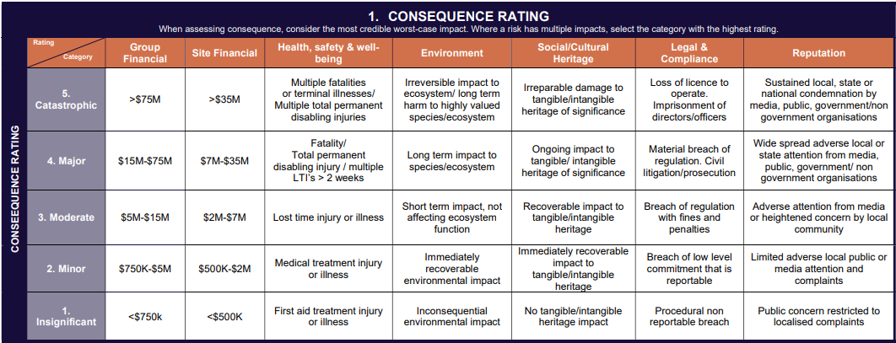

Likelihood Rating
The likelihood of an event (refer to Table 18) ranges from A (Rare) to E (Almost Certain).
Table 18: Likelihood of an event
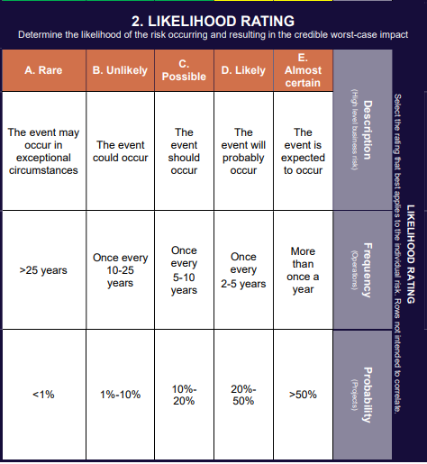

Risk Ranking
The risk ranking which combines the consequence and the likelihood of an event is used to determine the credible worst case impact (refer to Table 19).
Table 19: Risk Ranking
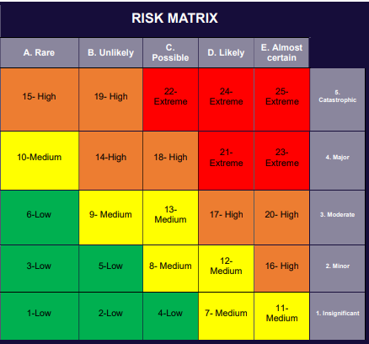

Risk Assessment
The risk assessment results summarised in Table 20 include the current controls and proposed mitigation measures.
Table 20: Risk Assessment of Wet Season Release EA Amendment
Risk Event | C | L | R | Justification and current controls
The site experiences a moderate to extreme weather event while a high water inventory remains onsite (target release volumes not achieved) and results in an uncontrolled release of MAW impacting on EVs of Gunpowder Creek. | 4 | C | 18 - High | The risk ranking has been designated without this amendment approval.  Approval of the amendment will allow for a higher volume of water to be released from site, reducing the current onsite water inventory and increasing storage capacity for an extreme weather event.
The water treatment process does not achieve target water quality below release limits and cannot be released, increasing risk of uncontrolled release from high water inventory. | 4 | B | 14 - High | Several MAW treatment strategies will be implemented onsite to achieve target water quality. Additionally, evaporators are being used to reduce the site water inventory.  Two water qualities have been proposed in the EA to account for variability in the water chemistry, particularly in the short-term whilst the temporary WTP is operational. Release limits have been calculated in consideration of past water treatment performance and should have a high rate of achievement.  See Section 7 for details of water management infrastructure and systems.
Water release equipment failure results in missed release opportunities and increases risk of uncontrolled release from high water inventory. | 4 | B | 14 - High | Several MAW treatment strategies will be implemented onsite to achieve target water quality, which provides contingency against failure or temporary suspension of equipment associated with a single treatment and release system. All pumping equipment will have standby/duty arrangements. The MCD release system and instrumentation is run off a diesel system and is not affected by power cuts.  See Section 7 for details of water management strategies, infrastructure and systems.
MAW released in accordance with the amended EA (controlled) impacts the EVs of Gunpowder Creek. | 2 | B | 5 - Low | The release risk assessment provided in Section 6.3 determined that releases undertaken in accordance with the proposed condition amendments provided in this document are likely to meet receiving environment water quality objectives and poses a low risk of impacts to the EVs of Gunpowder Creek. The risk assessment models the worst-case scenario water quality releases within compliance conditions (as if all release water concentrations are at the release limit i.e. the maximum allowed), however it is likely that most parameters will be well within the release limits most of the time (limits are set at higher levels to allow for variability within treated MAW storages).
Release water (controlled) exceeds release limits (not in compliance with amended EA) and impacts the EVs of Gunpowder Creek. | 2 | B | 5 - Low | As the real-time monitoring station W1 detects the release water pH or EC approaching EA release limits, an alarm will trigger causing preparation for shutdown of the release. When the pH or EC at W1 reaches the EA limits, the release will automatically shut off.  Receipt of daily laboratory results in exceedance of EA release limits will automatically trigger an exceedance notification and the release will be shut off.  There is also contingency built into the release limits, release risk assessment and dilution ratios which will serve to buffer potential short-term exceedances experienced due to laboratory processing times.  See Section 7.3 for a full description of responses to exceedances.
The background creek flow drops below 2 cumecs during a release and conditions are no longer within compliance. | 1 | A | 1 – Low | As the real-time monitoring station at GPA2 detects the creek flow approaching 2 cumecs, an alarm will trigger causing preparation for shutdown of the release. When the flow at GPA2 reaches 2 cumecs, the release will automatically shut off.  If the communications link to GPA2 fails the release will automatically shut off.  See Section 7.3.2 for details of the automated release management process.
Impact to groundwater quality and quantity from release of higher volume of MAW per year. | NA | NA | NA | CCPL have finalised a site-wide groundwater model after installing an additional 13 groundwater bores and will use this model to plan and undertake a comprehensive seepage and groundwater impact investigation and assessment.  Whilst CCPL acknowledge there has been seepage from legacy mining infrastructure onsite, the assessment of groundwater is not relevant to this particular amendment.  See ‘Pre-existing Impacts’ in Section 8.3.
C = Consequence
L = Likelihood
R = Risk ranking

Stakeholder Engagement
CCPL have developed a Stakeholder Engagement Plan to outline the objectives and protocols regarding engagement with key stakeholders. The Engagement Plan presents an overview of the engagement undertaken by CCPL to date, the current engagement context and issues and provides guidance regarding the delivery of stakeholder engagement and its documentation and monitoring.
The site Environment & Community (E&C) team are responsible for the implementation of the Engagement Plan, as well its review and update, in collaboration with the Community Consultative Committee (CCC). The CCC is comprised of representatives of community and other interested / relevant stakeholders that are active participants in the local community and represent the community’s values and issues.
Community notification and consultation is facilitated via the CCC with meetings held at least twice yearly, pre and post each wet season, and in the lead-up to significant operational changes. In the context of the Water Release EA amendment, this includes providing opportunity for feedback and input from stakeholders with a genuine interest in the impact of water releases on Gunpowder Creek.
The CCC has a number of documents and templates to capture the communication and collaboration undertaken in these meetings, including
- Stakeholder database template.
- Feedback Form
- Community Reference Group Charter & Code of Conduct.
- Meeting Minutes template.
- Nomination form for membership of the CCC.
CCPL records all interactions including engagement events, enquiries, complaints with stakeholders. In 2023 a Consultation Manager (CM) database was adopted, enabling tracking of all stakeholder interactions and actions. CM is used to ensure complaints are logged and acted upon in a timely manner. Statistical data can be easily gathered and reported on through the CM. Reports generated feed into corporate ESG reporting and enable the team to analyse current and emerging issues and tailor engagement tools accordingly.
Community engagements have been held during which contaminated water inventory and management measures were discussed as listed in Table 21.
The Stakeholder Engagement Strategy will be provided to DETSI with the IR response on 31 October 2025.
Table 21: Community engagements relevant to CCM contaminated water inventory and management measures
Date of engagement | Participants
29/04/21 | Landholders, Queensland Department of Environment and Science (DES)
19/11/21 | Landholders, Kalkadoon Native Title Aboriginal Corporation RNTBC (Kalkadoon PBC), DES
11/10/22 | Landholders, Southern Gulf NRM, Mount Isa City Council (MICC)
05/09/23 | Landholders, Southern Gulf NRM, MICC, Mount Isa to Townsville Economic Development Zone (MITEZ)
03/10/23 | Landholders, DETSI
11/10/23 | Southern Gulf NRM, DETSI
26/10/23 | Kalkadoon PBC
02/02/24 | Landholders, Southern Gulf NRM, DETSI
07/03/24 | Landholders, MICC, Southern Gulf NRM
13/03/24 | Calton Hills
17/04/24 | Calton Hills – site visit
18/09/24 | Landholders, DETSI
14/11/24 | Landholders, DETSI, MICC, Queensland Office of the Coordinator-General (OCG)
20/11/24 | Calton Hills
31/03/24 | Kalkadoon PBC
16/04/25 | Landholders, Southern Gulf NRM, DETSI, OCG
17/04/24 | Calton Hills – site visit
18/09/24 | Landholders, DETSI
14/11/24 | Landholders, DETSI, MICC, OCG
20/11/24 | Calton Hills
31/03/24 | Kalkadoon PBC
16/04/25 | Landholders, Southern Gulf NRM, DETSI, OCG

References

ANZG 2018, Australian and New Zealand Guidelines for Fresh and Marine Water Quality, Australian and New Zealand Governments and Australian state and territory governments, Canberra, Australia, <https://www.waterquality.gov.au/anz- guidelines/guideline-values>.
Engeny (2023) Gunpowder Creek Release Assessment, memo from Tim Wallis to CCPL, dated 21 August 2023.

Receiving environment sites include GPA4, GPA5 and GPD1.

